District Header and Login Page

You can use this place to give information that might be announcements, general information, or a logo, or other images or links. This option is used for information you may want to add/maintain that will display on the district login page.

This can be accessed by navigating to Product Setup > District Setup > SkyPort Setup then select District Header and Login Page Setup.
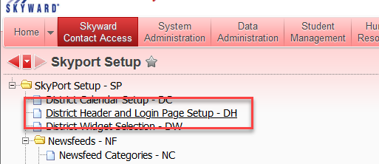
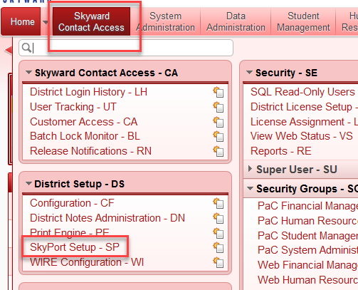

Headers and Footer are maintained here. You can use the various options such as font, color and alignment. Sample options like bold, underline, undo, redo, copy, paste and other buttons are available.

Type in your message. You can format it by using the buttons across the top. If you want to move down the header click enter above the message till the message is where you want it. On the Footer go to end and click Enter to move it up to where you want the message.
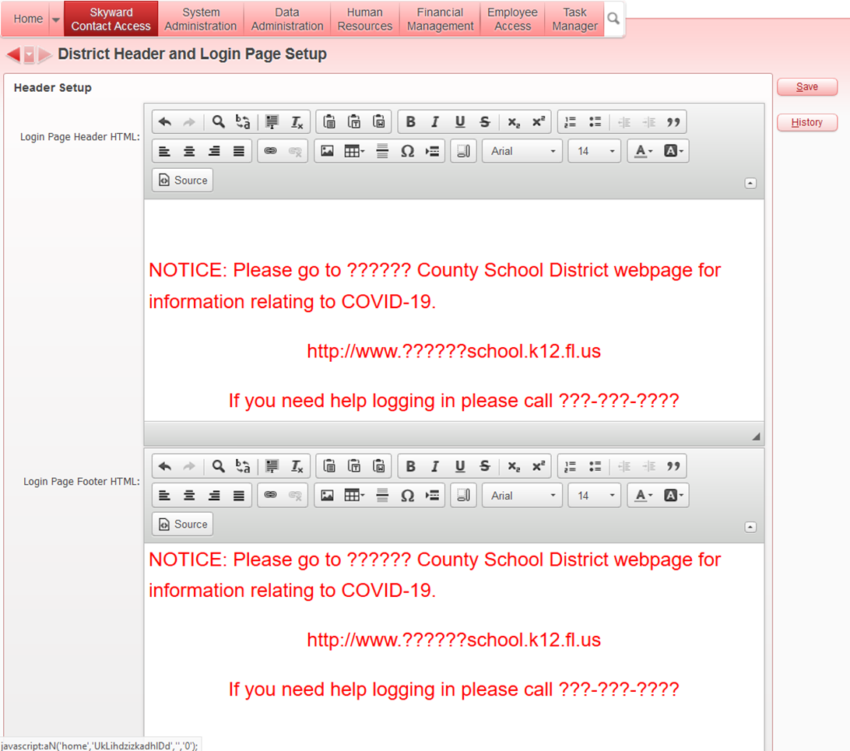

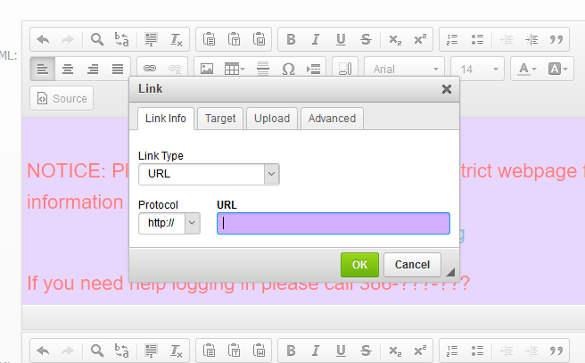
You can insert a hyperlink.
IE: your district webpage or anywhere you want them to navigate to.

Sample on what it could look like. 