Teams Quiet Hours
Here are the steps to set the quiet hour options for Teams app on Android; iPhone steps may vary.

- Click the three horizontal menu bars.

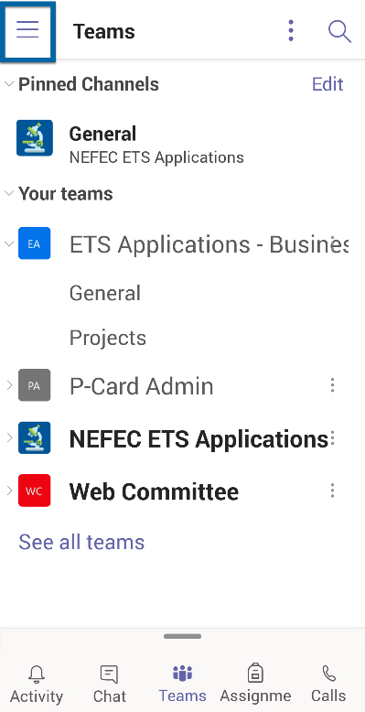

- Select Notifications.

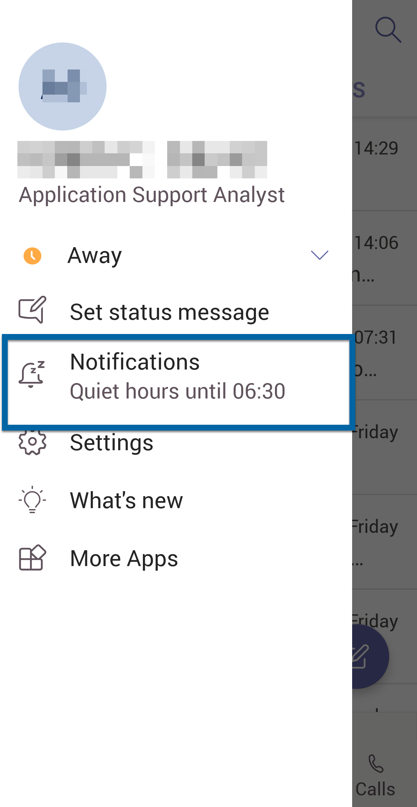

- Tap Quiet Hours.

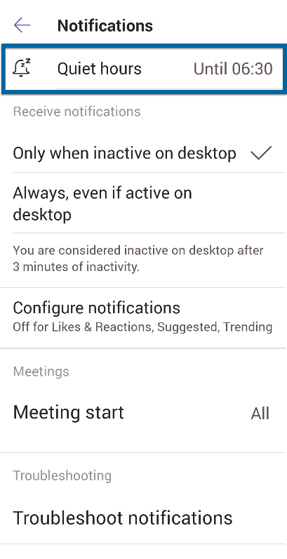

- Tap Daily quiet hours to enable. Next, click on the Start and End time to set those times.

