Outlook Email Notification Popup
Here are the steps to create an email notification popup in Microsoft Outlook. The popup appears in the middle of the primary screen over any active application to alert the user.

- Right click on an email from the sender to create the notification rule. Select Rule > Create Rule…

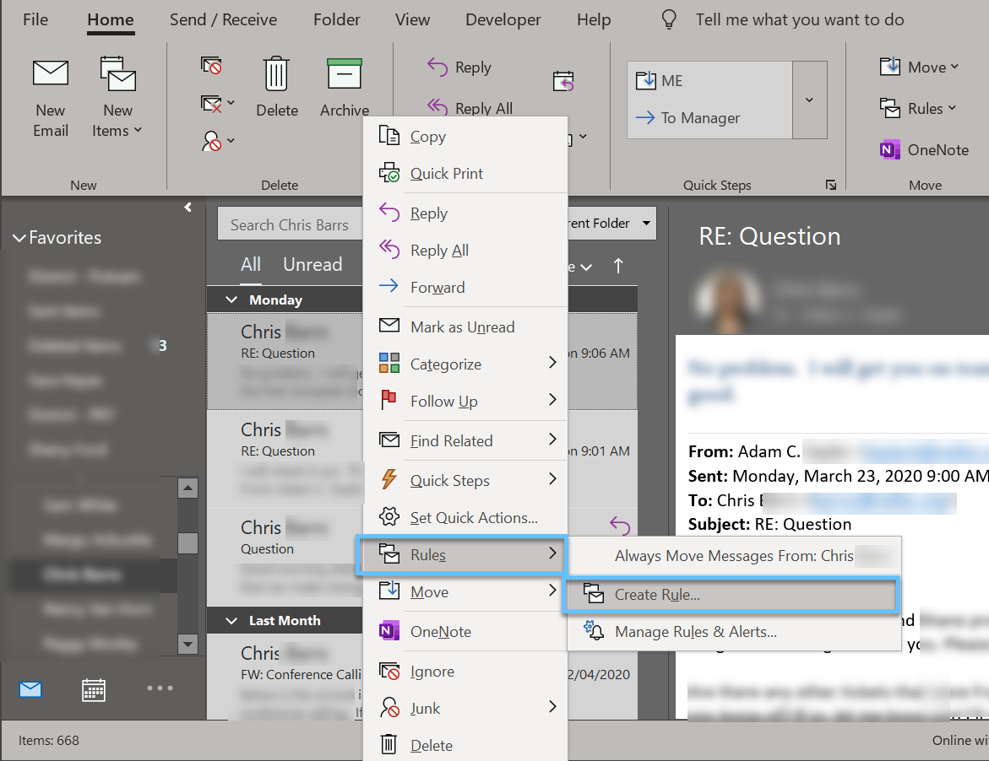

- Select the following. Click Advanced Options to send emails to specific folders, create automatic replies, or to set further parameters. Click OK to complete the setup.

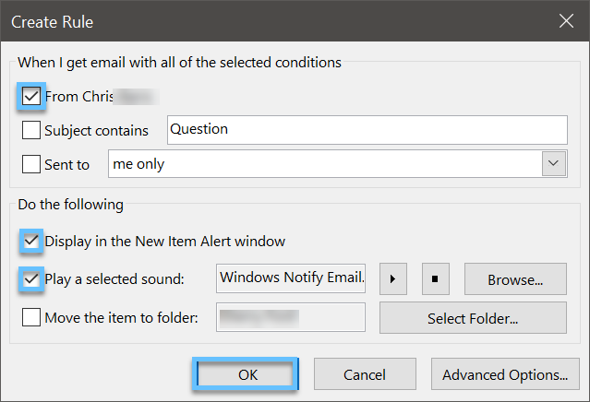

- Emails will arrive with a sound and popup notification.

