Microsoft Flows Email Reminder

- Go to: https://flow.microsoft.com/. Click Create.

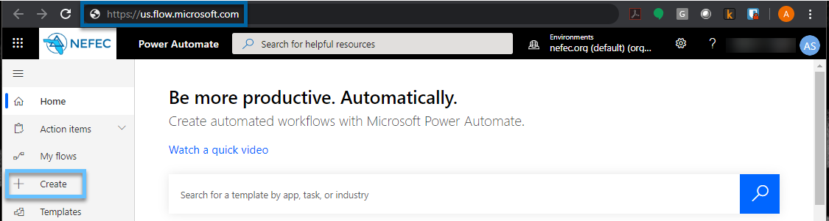

- Select Schedule flow. Microsoft often changes what it calls this, as of March 2020 this is what Microsoft called the specific flow option.

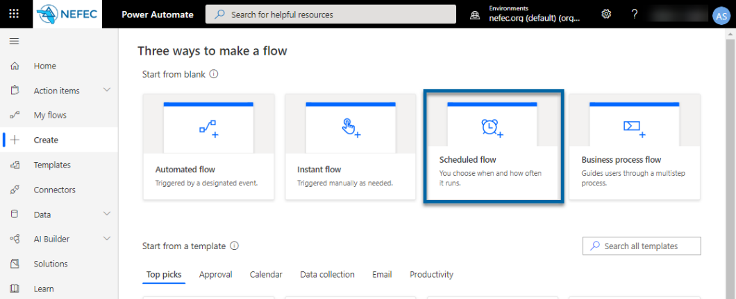

- Microsoft will begin a wizard to guide you through the process. Provide a process name, start date, and repetition cycle.

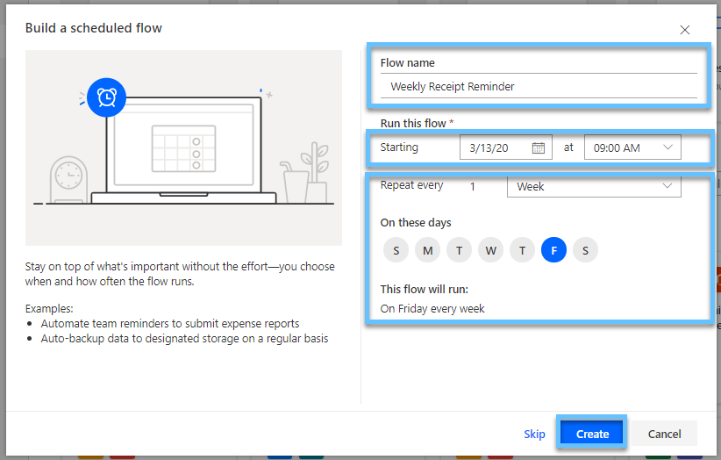

- In the search box, (1) search for email. (2) Select the mail icon as shown.

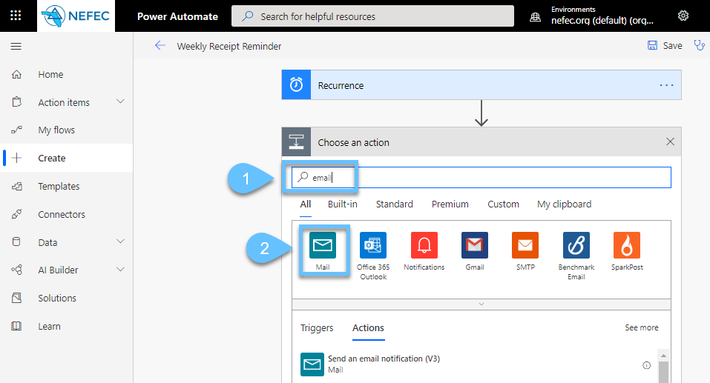

- You will need to click it again.

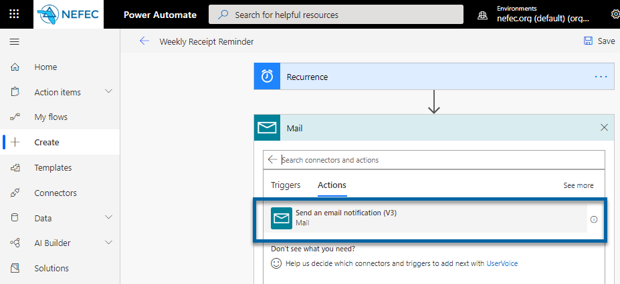

- Enter email address(es), subject line, and email message. The Show advanced options expander will allow you to cc, bcc, add attachments, and other features that might be useful. If other steps are necessary, click the Next Step button; otherwise, click Save.
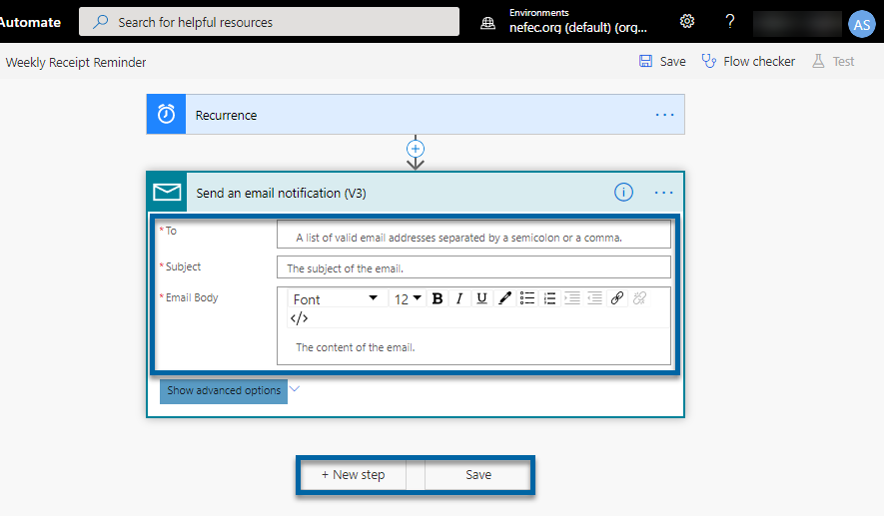

- To review current flows, click the My Flows tab. From here, you can send the flow on demand or edit as needed.
