Excel Dates w/ Leading Zeros

- Excel inherits a user’s Microsoft Window’s date/time settings. By changing the date format in Windows settings, Excel will stop removing the leading zero from months and days. Right-click the time in the lower right corner of you the computer screen.
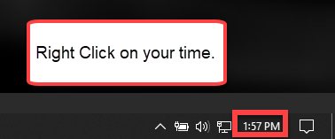

- Click on Adjust date/time.
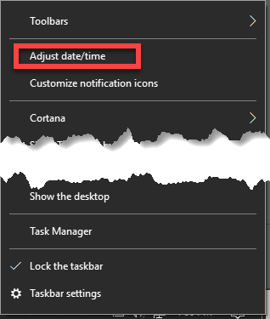

- Click Change date and time formats.
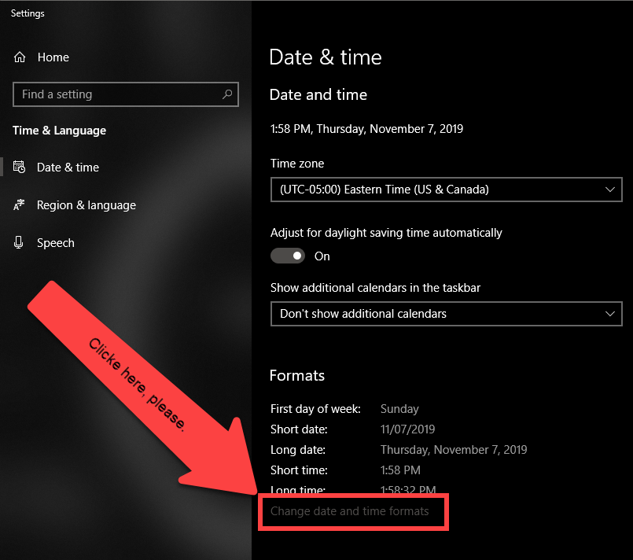

- Adjust Short date to the MM/DD/yyyy format.
