Fast Track Procedure guide

Logging in to Skyward

- Everything FAST TRACK related will be handled through the business log in so be sure to be logging in to your Business Database. The Log in screen should look like the below picture:

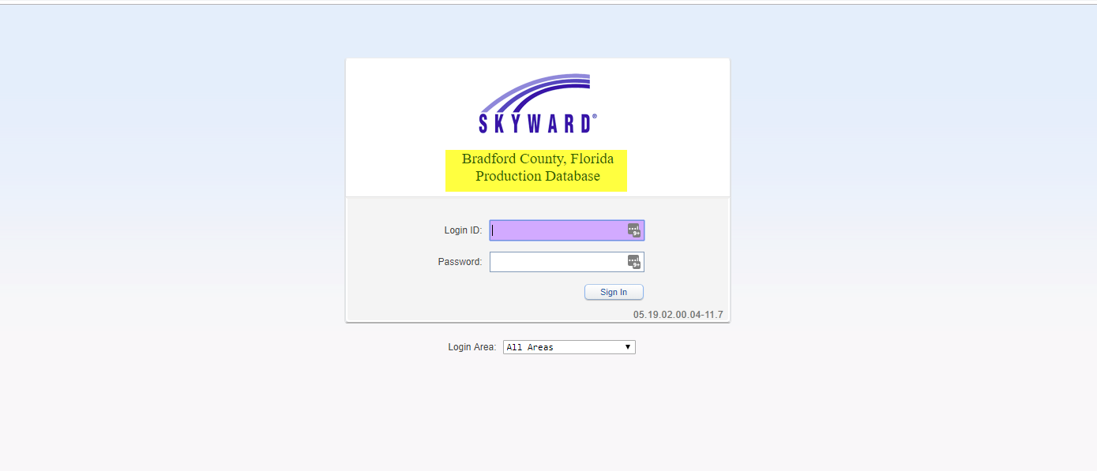

Requesting a Position to be posted

Once logged in to Skyward Business you may see a screen similar to below:

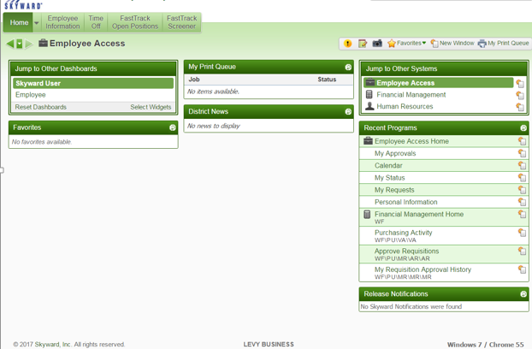

In order to Request a position to be posted to Fast Track, Follow the below steps:

- Navigate to Human Resource domain (Use Drop down to select Human Resources If employee admin tab is not available) and Select Employee Administration:

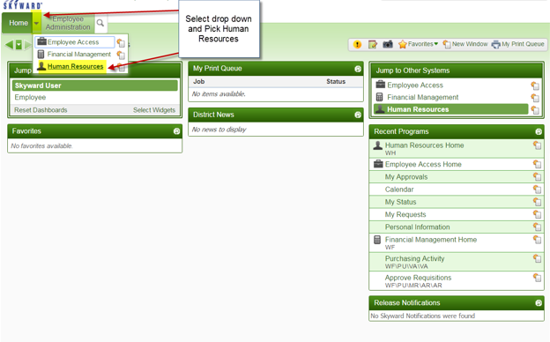

- Once Employee Administration Tab is selected, choose “My Positions” Under position Request:
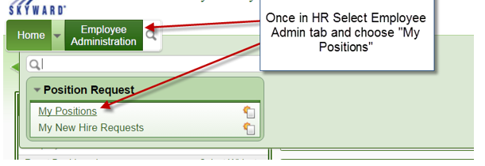
- When at the “My Position” screen, select the position you are wanting to receive approval on and select “Add New Hire Request” Button. If your screen “My Positions” is blank, be sure to select an Active Plan at the top of the page:
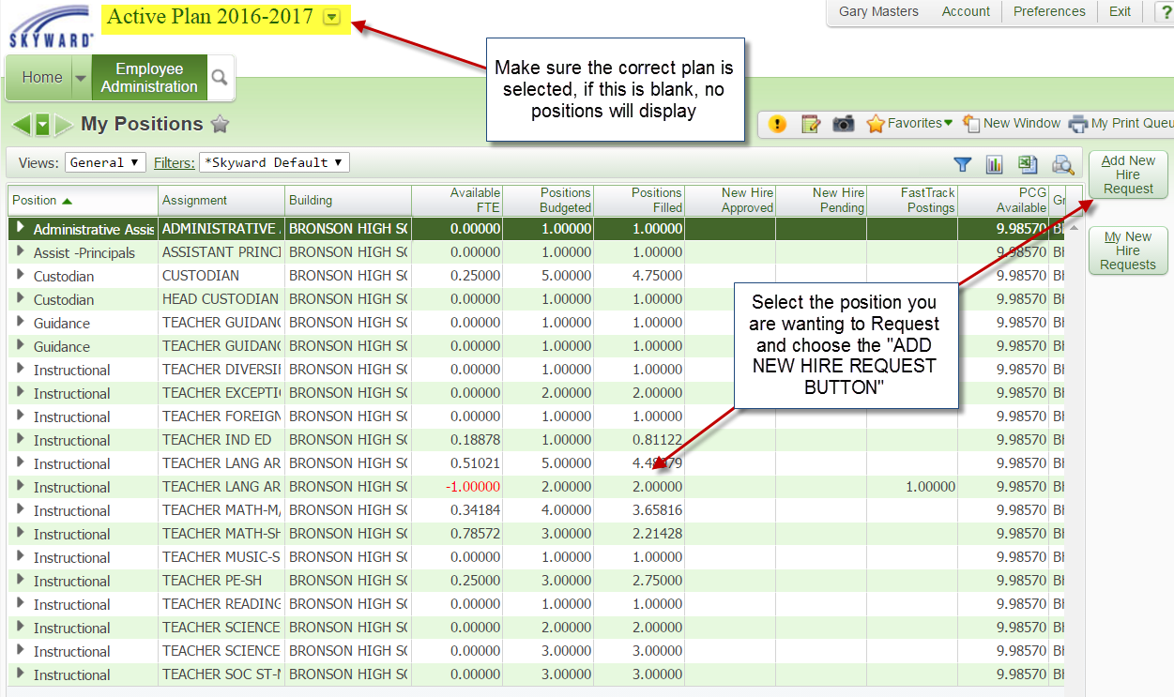

- Once you have selected “Add New Hire Request” You will be taken to the screen pictured below. Fill out the top two boxes (highlighted in the below image) and choose “Submit For Approval” option. 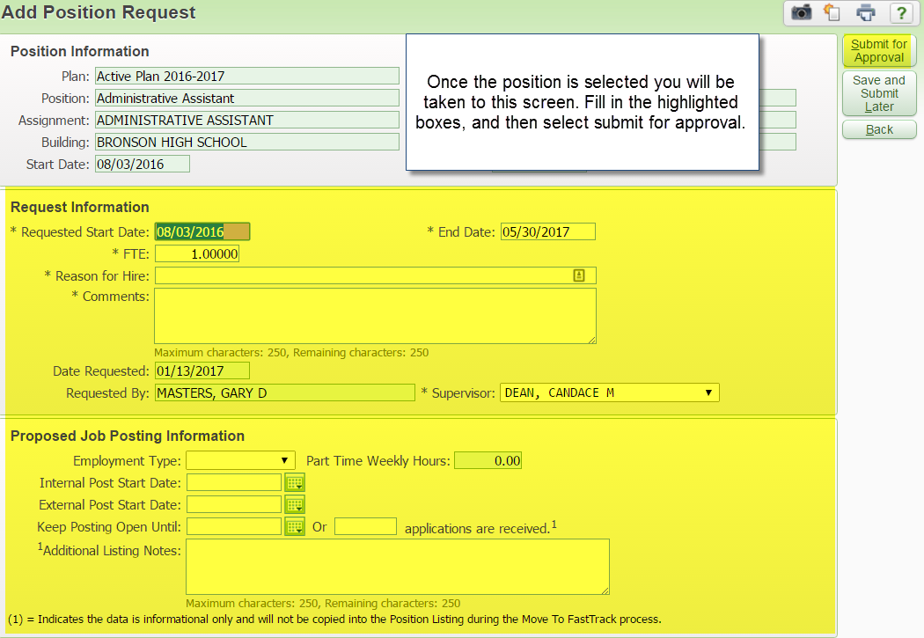

- In Order to check status of request Select “Employee Administration” Tab and choose “My New Hire Request”
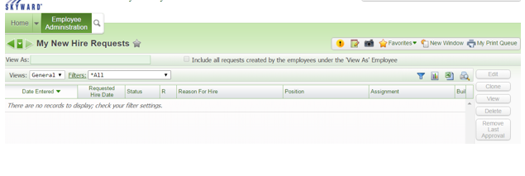

Receiving Applicants and Changing Status Codes

When a position has been posted to Fast Track, the Screeners will be notified by email as well as a notification within Skyward when individuals apply. Follow the below steps to view these Applicants.

- In order to view applicants who have applied, select the drop down arrow next to the home button and choose EMPLOYEE ACCESS. You can also select the yellow exclamation point on your user bar to take you directly to the applicant. See below image:

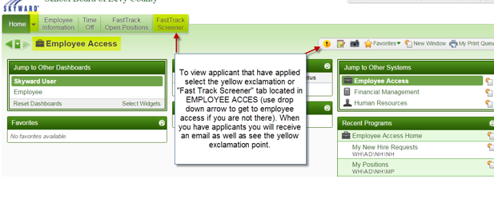

- If you choose to view applicants without using the yellow exclamation route, you can do so by selecting the “Fast Track Screener Tab”. Once here, you can select Open Applications (shows all your applicants regardless of position) or Application By Positions (Cleaner View):
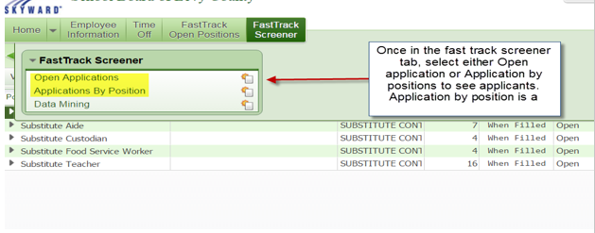

- Once in “Application By Position”, you will see a list of all your positions. Select the position you are wanting to see the applicants for and choose “view applications”:
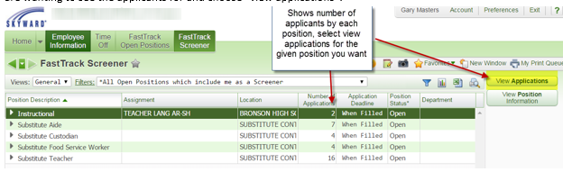

- When you are viewing your applicants you have many options. You can expand by the applicants name to view their information OR you can select View application information which will give you a cleaner view of their information as well as the option to print this information. The most important tab is SHOW MODIFY APPLICATION STATUS. This option will allow you to change the code on the specific applicant and allow you to move them through the system:

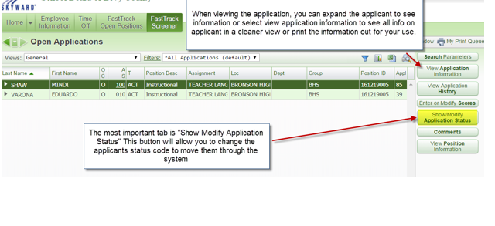

- After you select “Modify Status” Option you will be taken to a new screen that displays the status history. To add a new status you will select “Add Status”. When selected you will be able to select a status from the drop down box and select save.

The most important and mandatory status codes are “395” and “400”. 395 is selected when you want to have the applicant approved for hire. You will select this code and email HR that you have added code 395 to an individual. When you receive the approval notice from HR for the applicant you will FIRST contact the applicant and offer the position, once the applicant confirms they accept the position you will then change their status code to “400”
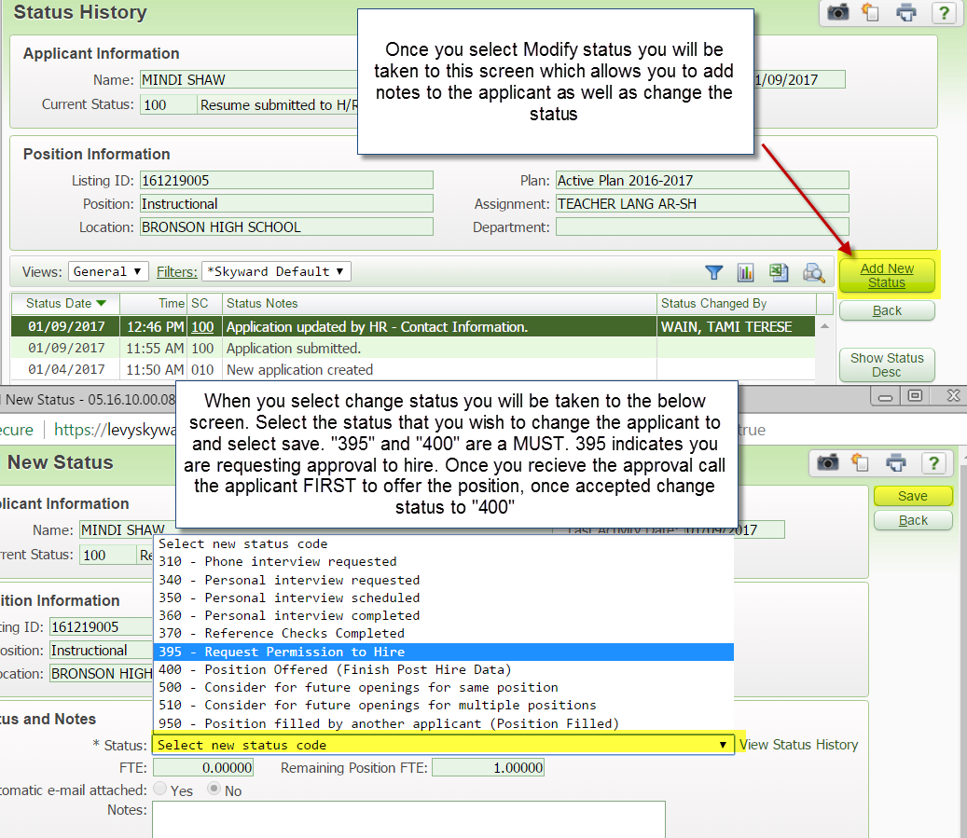

Quick Guide to work flow:
- Applicant applies
- Screener gets notification of applicant and views in open application option under fast track screener tab
- Determine applicants you would like to interview or progress to next step and use modify work status
- Required status codes are 395/400
- You will use 395 to recommend for hire
- Once HR changes applicant to 398, you will contact applicant have them accept the position and change their code to 400.
Code Cheat Sheet:
