Pivot Tables

Sometimes a pivot table in Excel provides a very helpful tool to sort and arrange data in meaningful ways. The following example will pull a series of cash receipts from Skwyard’s SBAA module to help with a bank reconciliation. Although this draws data from bank reconciliation, the basic idea applies throughout Skyward.

- This example uses cash receipts from SBAA, however, you can choose a separate browse view in Skyward. Click the Export to Excel icon located to the upper right of the browse view. Select the .XLSX option. Click Download Export File. Save file to your computer.

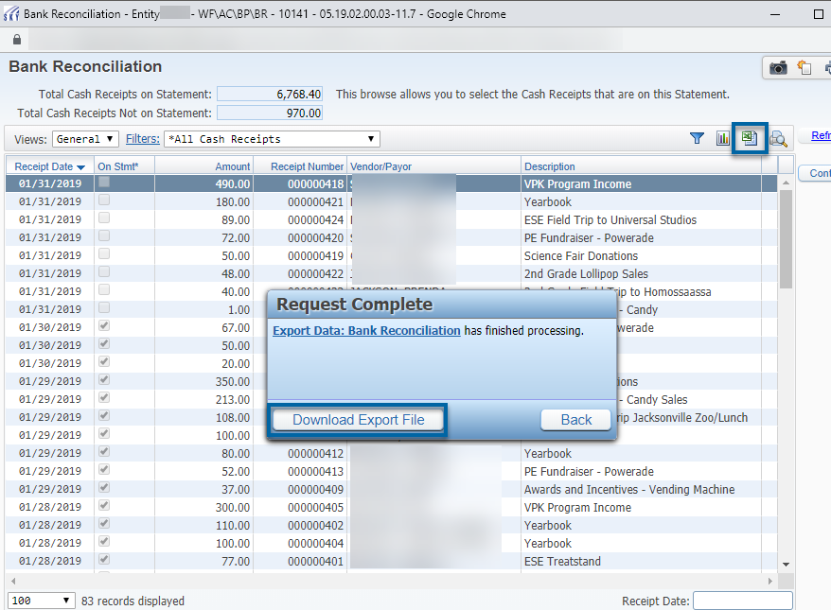

- Open the spreadsheet and click the Enable Editing button.

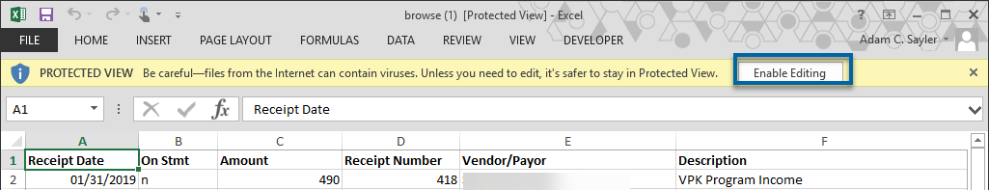

- On the Excel ribbon, click on the Insert tab. Make sure that you have clicked in a cell that contains data. You cannot have an empty cell selected. In the example below, I have selected cell A1. Click the PivotTable button.

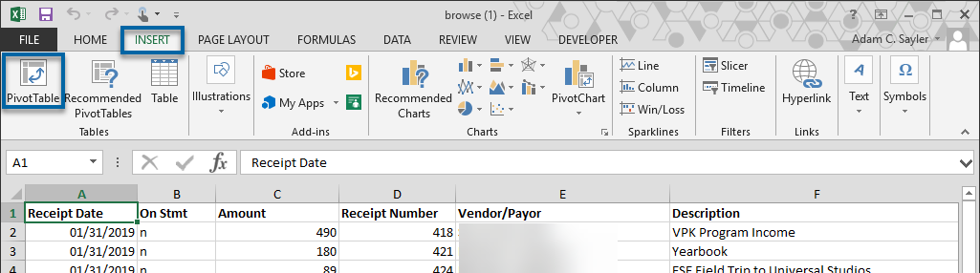

- On the Create PivotTable dialog box, just click the OK button.

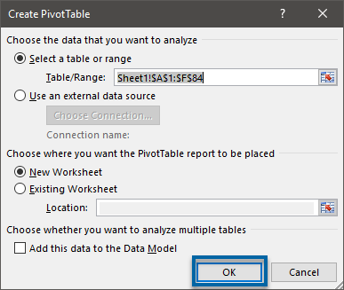

- To make a view as shown below, drag Receipt Date into the ROWS box, and drag Amount into the VALUES box. The FILTERS box allows other limiting parameters. For example, in this example, if On Stmt were dragged into the FILTERS box, then the options of “YES” or “NO” could be selected. Similarly, if Vendor/Payor were dragged into the FILTERS box, then the user could search for the receipts of a specific vendor arranged by the receipt date. The fields can be dragged into the various PivotTable Fields to present the data in different ways.

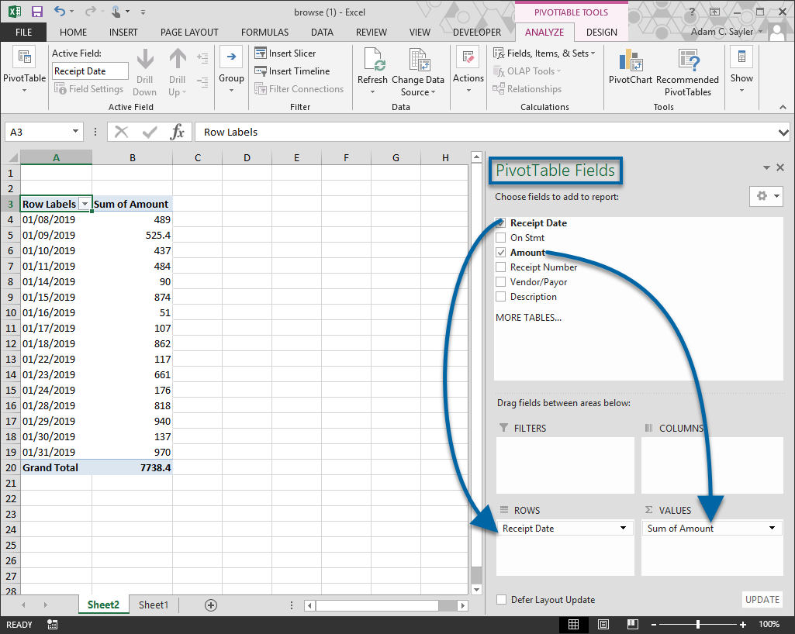

In addition to the user of filters as described above, you can click the down arrow on your table and choose to show certain dates (or whatever data you have selected). The total will update as you select/unselect data.

