SBAA – 1099 Cheat Sheet

To create 1099s for SBAA vendors the data must be extracted from SBAA for use in Skyward’s annual 1099 process. This process of extracting the data takes place at the district level and often in coordination with NEFEC. In order for the district and NEFEC to pull the appropriate vendor data there are two crucial pieces that need to be addressed: (1) the SBAA vendor’s 1099 information; and (2) the 1099 check box on SBAA check requests. These two pieces of data help assure that the correct information available when creating 1099s.

- SBAA Vendor 1099 Information – In order to check this information, in the web, please go to: Financial Management\SBAA\Vendor/Payor Names. Select a vendor record that needs 1099 information updated and click the Edit button. Update the 1099 information for the vendor as appropriate and required by the Internal Revenue Service's W9 requirements.
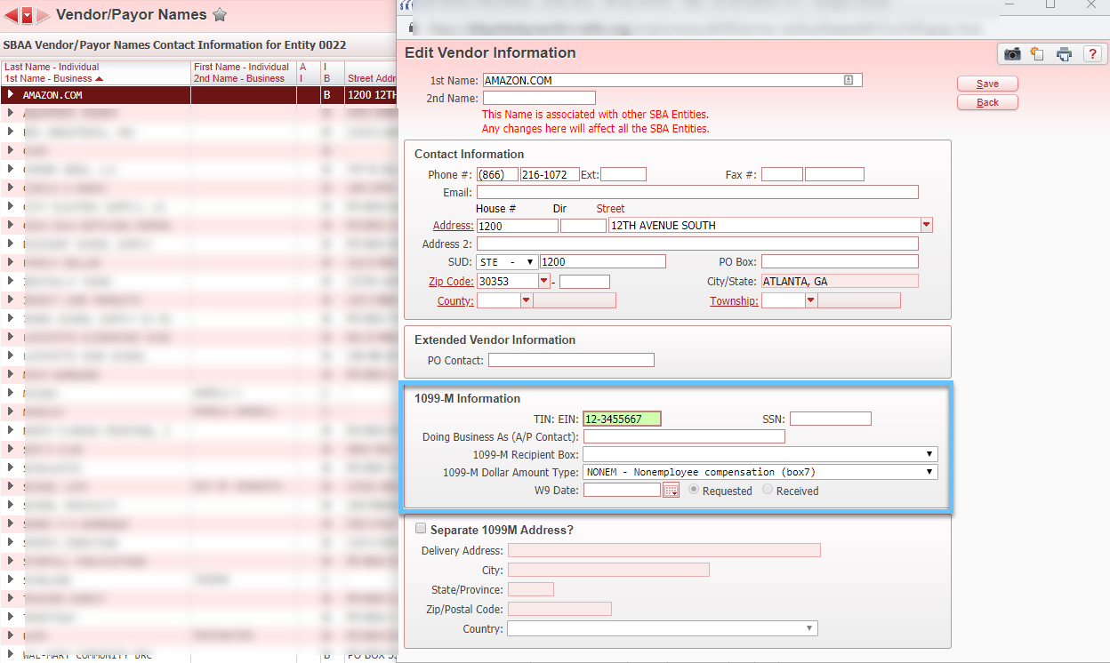

- SBAA Check Requests – The best time to make sure that a payment to a vendor should appear on a 1099 is at the time of the check request. Unfortunately, this does not always happen. Once check requests have been moved into history, the 1099 flag on a check request can still be selected by going to the vendor’s profile in Skyward, selecting the check, and updating the flag.

  - Select the vender and expand until can you can see the check requests. This view will show payments and what portion of those payments were considered a 1099 payment.
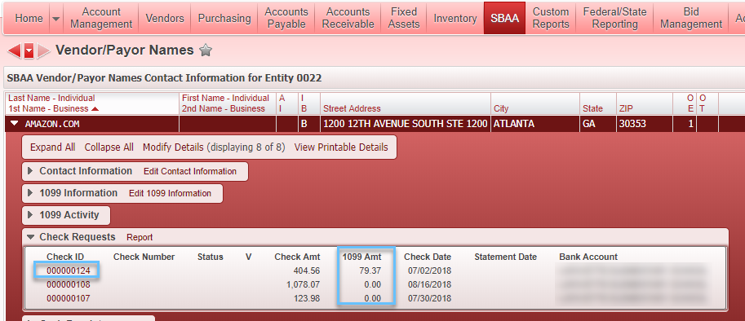

  - After click on the Check ID number as shown in the above example, you can then check the 1099 box as required by the IRS for Form 1099.
