Remove Batch Lock

- In the web go to: Product Setup\Skyward Contact Access\Batch Lock Monitor.
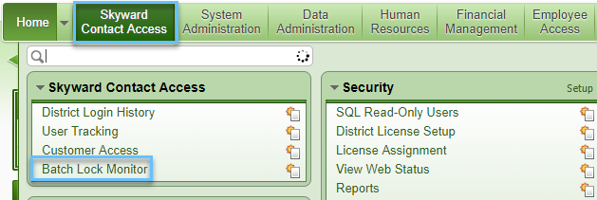

- Select the locked batch. Click Remove Batch Lock.
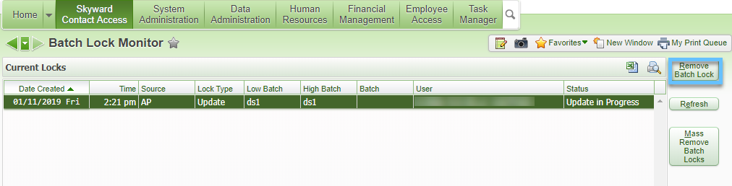

- Provide a reason that is at least 50 characters long. Click the Save button.
