EOC CONFIGURATION and PROCESSING STEPS for FSAA- Performance Task
Access Course EOCs
- Build the EOC Import Codes- From 000- WS/OF/CA/TS/PS/CO/EO
Create the EOC Import Code for each of the following FA1 subtests:
- Algebra- FA1UE
- Geometry- FA1UF
- Biology- FA1UG
- US History- FA1UH
- Civics- FA1UI
Choose the radio button for *Xref Based on: Year
You can use the same code on the test builder record when creating the Import Codes, or you can create a different code. The EOC Import Code does not have to match the test builder code.
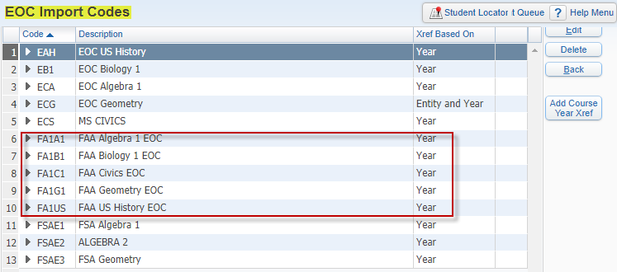
These codes tell the system how to interpret scores for each of the EOC exam files when imported.

- Create a Score/Grade Xref table for the current school year

- You will need to do this for each import code
- There are no rules from the FLDOE that mandate which grade mark is associated with a particular range of test scores. However, District Policy will often dictate how test scores should be cross referenced.

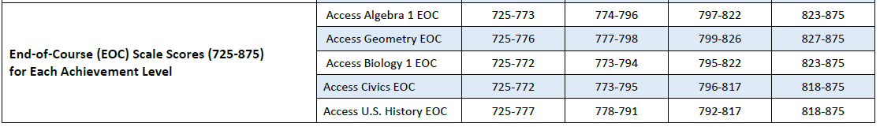

- Note-The FA1 cuts only allow for 4 levels. Typically when cut scores include 5 Levels, each level is associated with a letter grade of A, B, C, D and F. Since there are only 4 Levels with FA1, the typical cross reference will need to be adjusted. Below is an example of how one District has established their Score/Grade Xref table for Access Algebra EOC
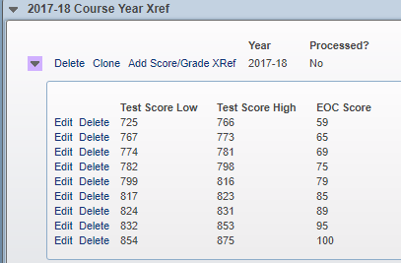

- Add Information to the Test Builder Record - From 000- WS/OF/CA/TS/TB
Do the following steps For each of the FA1 tests- FA1UE, FA1UF, FA1UG, FA1UH, FA1UI
Open the node on the test record and expand to see EOC Details area
- Under EOC Details- Add Course Links
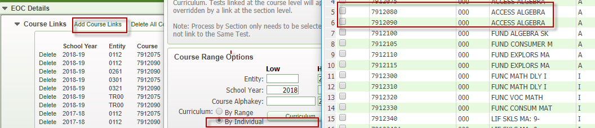

- You may want to include TR00 courses because the EOC Assessment Details Area looks at courses that are attached to the state tests to know which Passed Calculated codes to enter for each student. So- if a student has a test score entered on the test score panel, but the system does not associate that test with a course that the student took, it thinks that the student has CAP’d the course and will create an “E” exempt code for that particular test.

- **Note- Attaching courses to tests results in creating EOC grade buckets on courses. If you do not see the EOC Grades buckets then you know the course is not attached to an EOC test.
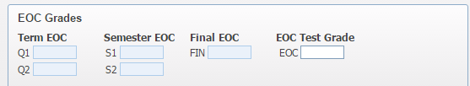

- Edit Import Setup- Connect the EOC Import Codes, Choose a Grade Mark Update Option, and Select a Score bucket
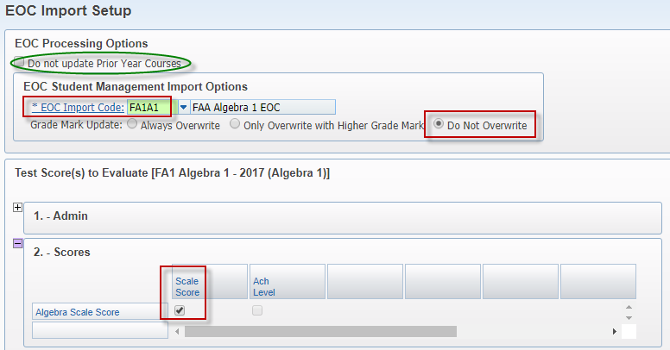

- There is a Processing Option for “Do not update Prior Year Courses”. This may be something you want to keep unchecked for Access course EOCs being that Access courses can be multiple credit and repeatable courses. There are options for students taking Access courses that could excuse them from taking the EOC in the first year of the course.
- Connect the appropriate EOC Import Code
- Verify that your Grade Mark Update is correct for the scores that are being imported. The most common choice will be “Do not overwrite”, however if you are importing scores for the Spring Administration, there may be students that took the test in the Fall or Winter Administration of the same year and have an improved score. In those cases, you will choose “Only Overwrite with Higher Grade Mark’.
- Verify that the radio button in the Scores section is set on the Scale Score column

- Date Passed Setup –
- The Access Algebra 1 EOC will be used as Graduation Requirement test and therefore necessitates the setup for Date Passed.
- Below is a screen shot of the FA1UE Date Passed Setup
- Grade Level When Test Taken- 07-12
- Test Section Information- Radio button in the Scale Score column
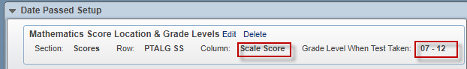

- Create EOC Grouping Codes and EOC Calc Methods- WS/OF/GR/PS/CF/GP/GP
This has to be completed at each entity using Alg, Bio, Geo, USH and Civics Access Courses
** If you are opting to use the exam bucket in the gradebook to record the EOC grademark and have the gradebook calculate the final EOC grade, then you do not need to setup EOC Calc Methods.

- The EOC Calc Methods tell the system which grade buckets to use when determining gpa and earned credit on EOC courses.
- The EOC Grouping Codes tell the system which group of courses to look at when applying the calculation method.
- Under GPA setup- click on EOC Calc Methods-

- Decide if you want to create new EOC Grouping Codes for Access courses or if you want to use the pre-existing codes-

- Although it is not necessary to create new grouping codes for the Access course EOC calc methods, it is recommended. Creating new grouping codes allows you to isolate just those access courses, or calc methods, if necessary, when running the EOC Grade Calculation Utility.

- If you decide to create new Grouping Codes for Access courses -follow these steps:

- Start by adding a new EOC calc method record

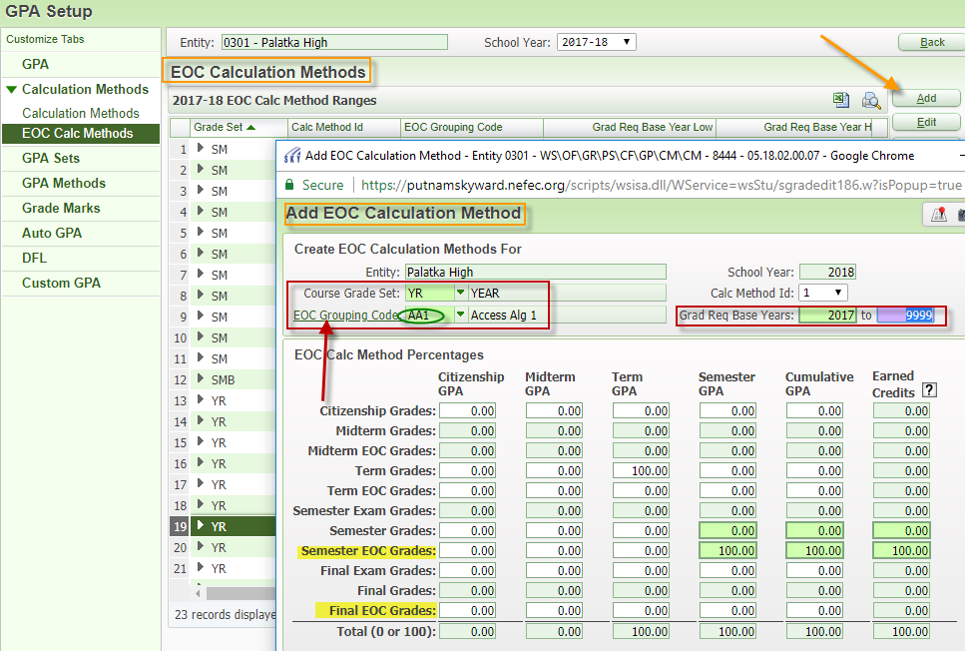
- From there, you can access the EOC Grouping Codes table and can create a separate code for each Access course requiring an EOC. Each of the following (Access Alg 1, Access Bio, Access Geo, Access USH, Access Civics) should have its own code.
- Verify the course length that is attached to the Access courses in your course master, so you know what course grade set to use when creating the EOC Calc method
- Decide which EOC buckets should be used for credit and GPA
- Create a new EOC Calc Method for each course length and each new Grouping Code
- ** Note- the system will only allow you to enter a 100.00 in the Earned Credits column if that grade bucket was used for earned credit on the original calc method.
- Attach the new EOC Grouping Codes you created to the appropriate Access course in the course master

- If you choose not to create new grouping codes for Access courses then you will only need to make sure that you have an EOC calc method created for the course length set that is attached to your Access Courses in the course master and Link the appropriate EOC Grouping Code to the appropriate Access Course in the course master.

- Course Master- From each entity- WS/OF/CS/BC/CM/CM
- Verify that all EOC courses have the correct EOC grouping code attached
- You can run the “Course Report by Course” report (Office>Scheduling>Build Course Master>Reports) by setting the format in your template to User Defined and selecting that field in the Course fields column. You can then export the report to Excel and filtering/sorting on Grouping code.
- Otherwise you should check every EOC course at each entity to ensure the correct EOC grouping code is attached in the EOC area.
- You can also verify that the EOC test links are correct from the same area

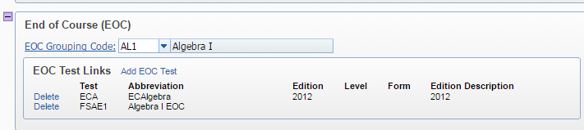

** Note- It may be a good idea to create a separate course length specifically for EOC courses in the course master. This makes it easier to filter in the course master as well as gives you the ability to isolate just one course length to make changes, if needed.

- Review Test Score Import Results reports
- Once test scores are imported into Skyward, you should receive a notice from John Colarusso at NEFEC as well as instructions on where to locate the Xcel spreadsheets and PDF reports resulting from the import process.

- Review the EOC Import Results PDF Report-
- Check for any unmatched demographic records that resulted in the test score information failing to load into Skyward.
- You will need to manually add these student’s test information on the test score tab as well as manually calculate the student’s final grade. The actual test score will be located on the Xcel spreadsheet, not the PDF.
- Check for any Xref table errors.
- Switching to the new option of processing by “Year” instead of “Entity and Year” should eliminate most of the errors we have seen in the past.
- There may still be some errors that reference no course for the student. The error will say “No Student Class record found for Student”.
- This will happen if the student is in fact is not enrolled in a course of which they are taking the test in the current year, (in which case they will be CAPing) or if the course the student is enrolled in is not linked properly to the EOC test in test builder.

**For steps 6-8, Please keep in mind that there may be situations where an EOC Results Waiver has been applied. This would alter the steps in processing final course grades for EOC courses.
In those cases, the best way to calculate the final grade on an EOC course, without reversing all the setup completed above, would be to check the box for “Exclude Class from EOC” on the student’s Class Grade record.
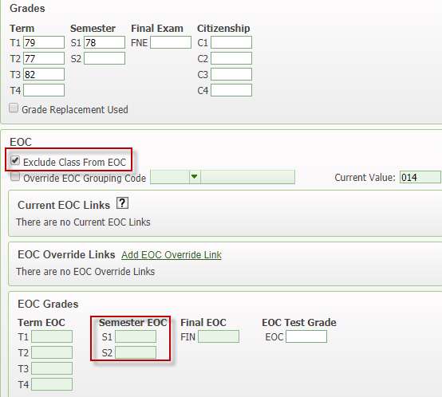
Using the Exclude option tells the system to calculate grades using the regular grade buckets but still allowing you to see the values contained in the EOC bucket.

- Run the “EOC Grade Calculation by EOC Import Run” Utility- From 000 or each entity- WS/OF/GR/PS/UT
If ran at entity level only student classes from the current entity in the Import Runs selected will be processed.

- Add a new template and select which test import to process -
- Click on “Select Runs’ to choose the test loads you want to run the EOC Grade calculation for. It is best to do one test at a time.
• When you check the box next to the import run you want, you can see the Student classes processed and the Exceptions that resulted from the test score import. That is basically the same information you saw when reviewing the test score import results PDF report. The exceptions will not be updated by this utility. You have to take care of those manually.
**It is a good idea to look at the “Student Classes Processed” so you know which courses you are updating when you run this utility. The “Student Classes Processed” browse will tell you the Entity, Year, all the students on the test file that will be processed and the course and section they are in. It does not tell you the course length or grade set of the class.

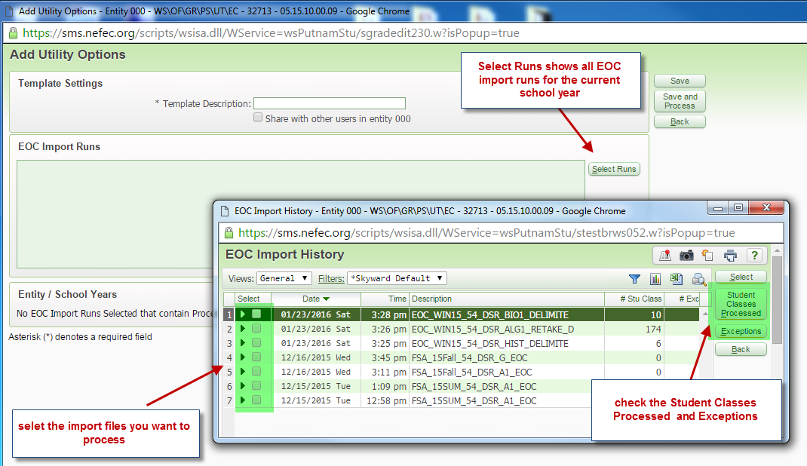

- Set up the calculation formula on your template and choose the appropriate Calc method-

- Based on what is selected in the step above, the screen will now have EOC Grade Calculation ranges for you to choose which EOC grade buckets to calculate and how to calculate them.

**You need to know if you are calculating a Semester EOC grade or a Final EOC grade for the courses associated with this test. So you need to know which course length set is attached to the courses you are running this utility for as well as which gradebucket your EOC Calc method is set up to use as Earned Credit.

If you are calculating Semester EOC grades, then your formula will be S1=70/EOC=30 and S2=70/EOC= 30

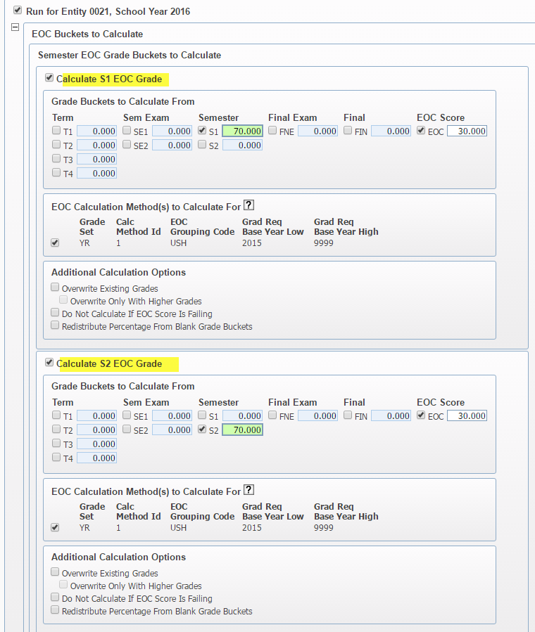

If you are calculating a Final EOC Grade, there may be two possible ways you calculate a FINAL EOC grade, either by semester grades and EOC or Final Grade and EOC.

Depending on how the Semester Final Default Formula is set up for calculating a Final Grade for this particular grade set- your formula will either be S1=33.3/S2=33.3/EOC=33.3 OR Final = 70/EOC=30
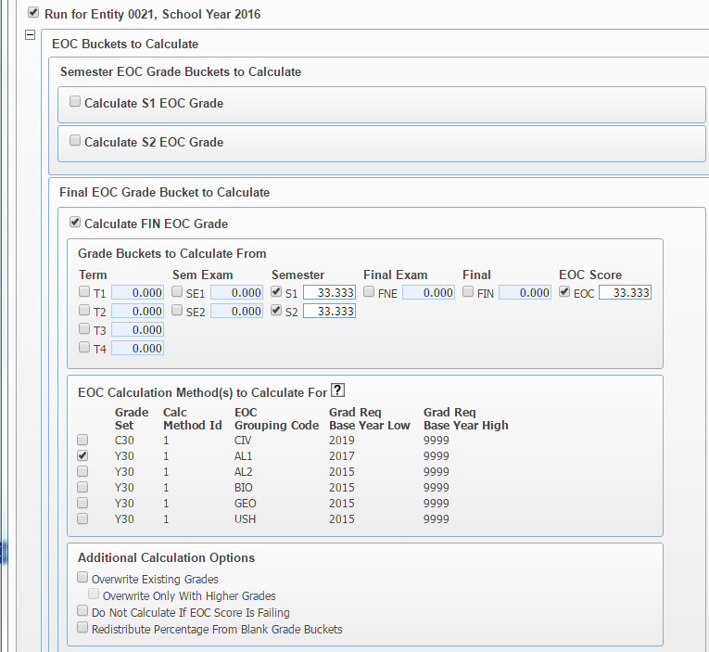

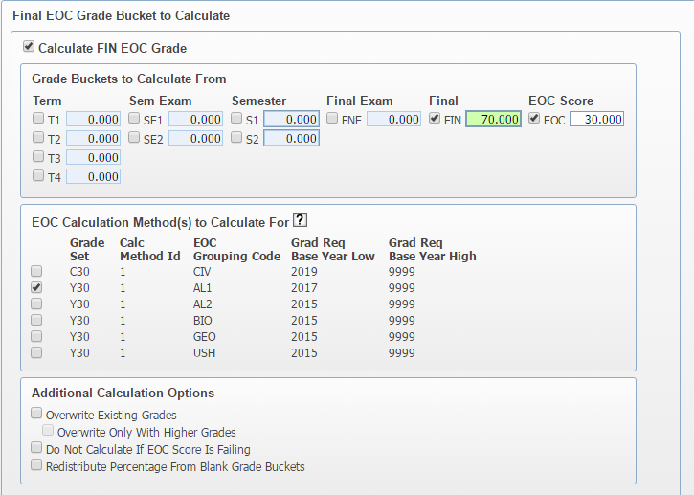
Make sure to check the box for the appropriate Calc Method formula to be used. If you are running this utility to process Algebra yearlong courses then you will check the box for Algebra grouping code and the corresponding grade set.

- Preview the Update –
- The utility will then provide a preview of the update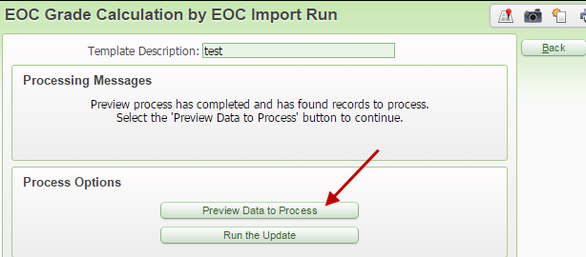
- You can remove selected students from the preview if needed
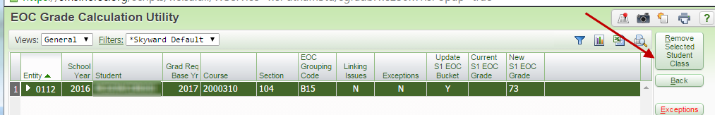

- Process the utility and review the report-
- Exceptions should be updated manually if they haven’t been taken care of already

- Hybrid Method using Gradebook
- Some Districts are opting to use the semester or final exam bucket in the gradebook to record the EOC Xref score and therefore setting up the semester final default formula to weight the exam bucket as 30%.

- This method eliminates the need to create EOC Calc Methods because you will not be using the EOC grade buckets. When the grade posts from the gradebook it will post in the regular Final grade bucket as opposed to the EOC Final grade bucket.

- This method also eliminates the need to run the “EOC Grade Calc by EOC Import Run” Utility. The grades are calculated inside the gradebook and posted when the grade posting window opens.

- There are some drawbacks to consider-
- This method works better when you are reporting one final grade in a yearlong EOC class versus reporting two semester grades in a yearlong EOC class. It also really helps to create a unique grade set specifically for EOC courses.

- Someone will have to enter the EOC Xref score into the exam bucket in the gradebook, it will not load automatically. This could present a problem if EOC scores are not back before teachers leave for the summer.

- Depending on when EOC scores come in, could require you to extend or re-open the grade posting window.

- The teacher cannot offer a final exam because the final exam bucket will be used for the EOC exam Xref score.

- You will see a message on all the EOC course grade records that says “EOC- Student Not Required to Take Test”. The system is programmed to show this message when the gradebucket used for determining earned credit is not an EOC grade bucket.
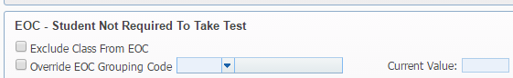
- There is a long standing PR to eliminate the message.

- How to Show EOC Scores and Grades as Viewable Columns in the Gradebook
- You can set up the Gradebook to show the EOC XRef Scores as well as the EOC Calculated Grade as a Viewable column in the Teacher’s Gradebook
From Each Entity- WS/EA/GB/PS/CF/ES
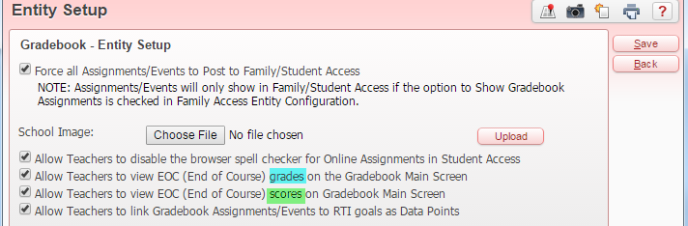
EOC grade buckets on a course calculating a Final EOC grade-
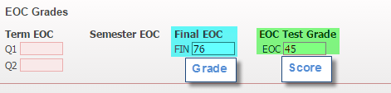
Gradebook main screen-
