FLORIDA STANDARDS ALTERNATE ASSESSMENT- EOC
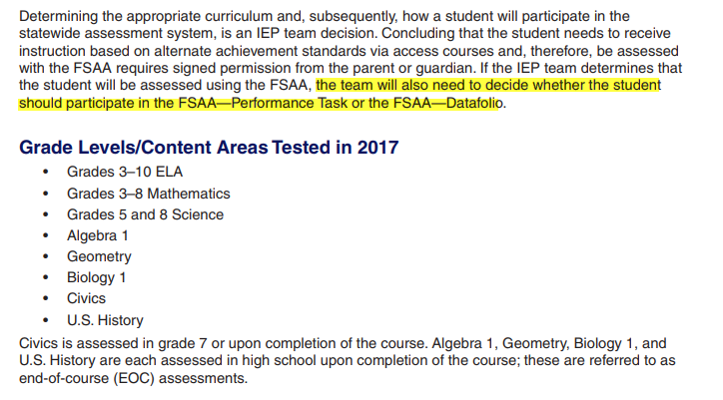
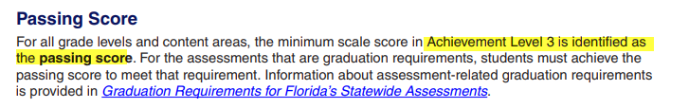

FA1- Performance Task
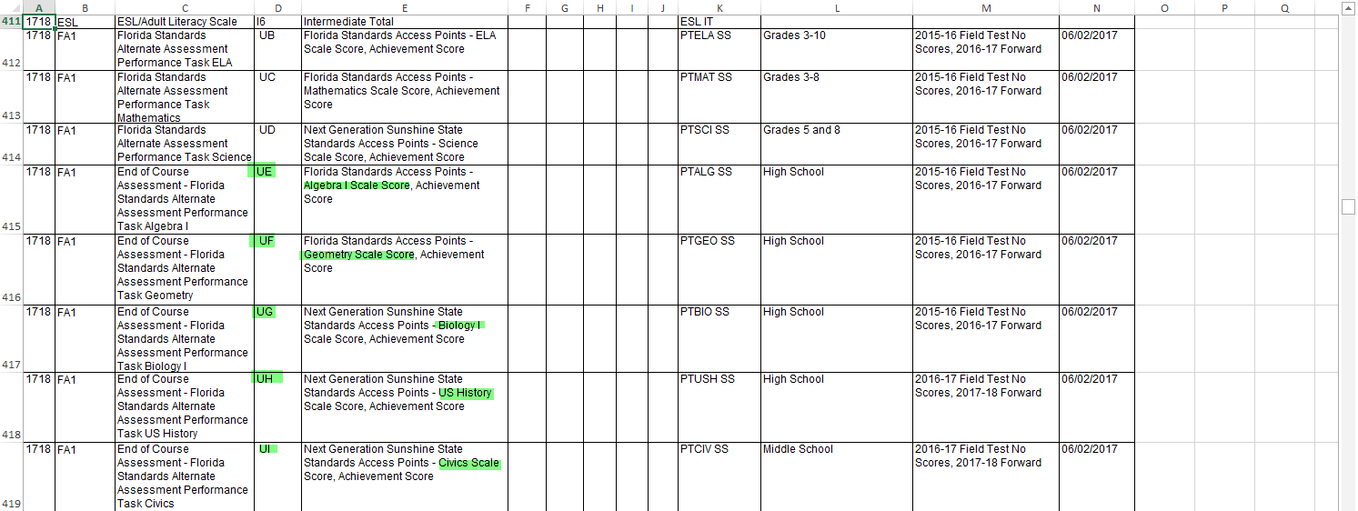
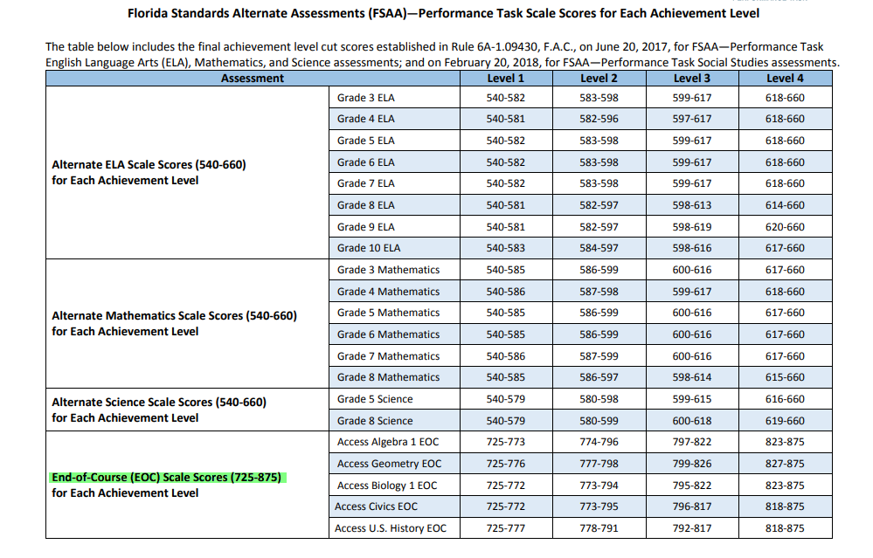
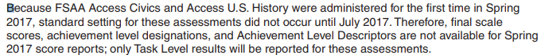

FA2- Datafolio
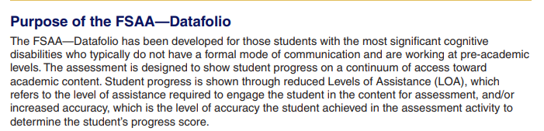
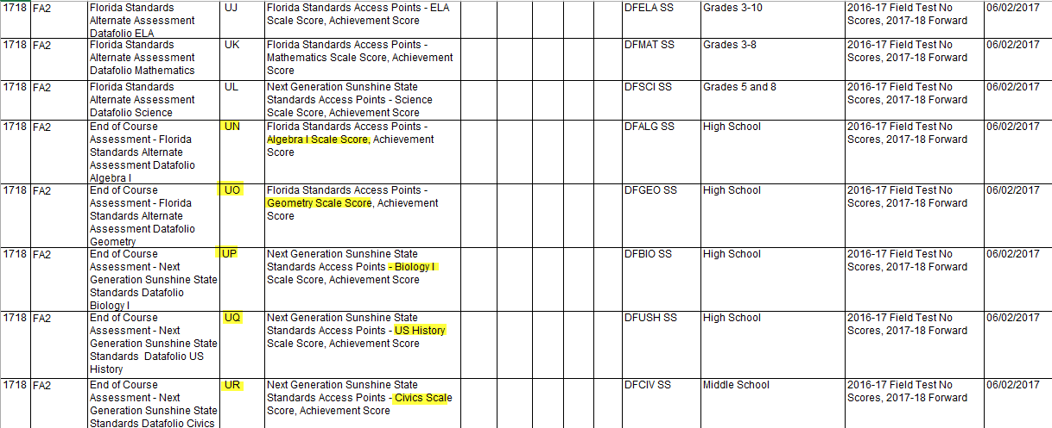

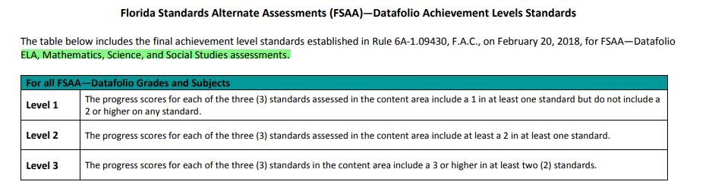

The FSAA—Datafolio measures the progress of students who require varying Levels of Assistance (LOA) to engage in academic content. The goal is to move the student along the continuum of assistance toward independence by decreasing the levels of assistance provided and increasing student accuracy within the context of content to show progress throughout the year. The following chart describes the LOA as they are used in the FSAA—Datafolio:
