EOC CONFIGURATION and PROCESSING STEPS- FSA/NGSSS
- EOC Import Codes- From 000- WS/OF/CA/TS/PS/CO/EO
These codes are what tells the system how to interpret scores for each of the EOC exams when imported. In years prior we had to create a cross reference table for each entity and year. Now we have the option to create one table for the year, we no longer need to clone to each entity.

- Switch the Xref option from “Entity and Year” to “Year”-
Switching to this new option will prevent the system from looking for historical records when deciding which courses to update
- To do that, you will need to edit the existing Import setup codes and switch the radio button from Xref Based On: “Entity and Year” to “Year”.
**A word of caution before doing so- you may want to take a screen shot of the current Xref values so that you know what to enter for the current year because when you switch to “Year” the old current Xref values will be hidden.
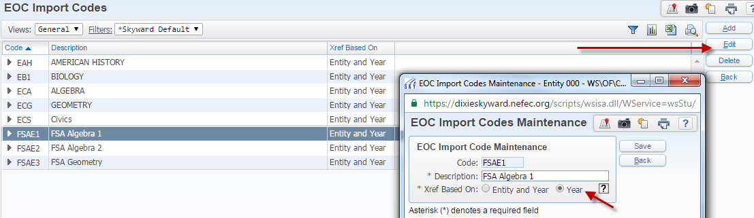

- Create the current school year Score/Grade Xref table-
- You will need to do this for each import code
- Effective July 1, 2017 the State Legislature removed the Algebra 2 EOC Requirement. You do not need to remove the Algebra 2 EOC Import Code or Xref table, It should stay for historical purposes.
- There are no rules from the FLDOE that mandate which grade mark is associated with a particular range of test scores. You can use the FSA and NGSSS fact sheet to reference Achievement Levels ranges.

- http://www.fldoe.org/core/fileparse.php/5663/urlt/FSAEOCFS1718.pdf
- http://www.fldoe.org/core/fileparse.php/5662/urlt/NGSSSEOCFS1718.pdf

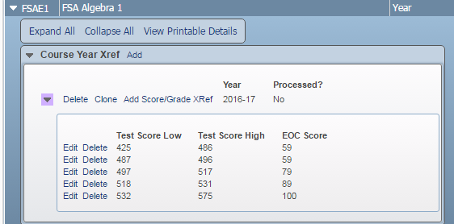

- Test Builder- From 000- WS/OF/CA/TS/TB
FSA tests- FSAE1, FSAE3
NGSSS tests- EAH, EB1, ECA (Algebra 1 retake), ECG (Geometry retake), ECS
Open the node on the test record and expand to see EOC Details area
- EOC Details-

- Verify Courses are linked for the corresponding school year and all entities including TR00
- You want to include TR00 because the EOC Assessment Details Area looks at courses that are attached to the state tests to know which Passed Calculated codes to enter for each student. So- if a student has a test score entered on the test score panel, but the system does not associate that test with a course that the student took, it thinks that the student has CAP’d the course and will create an “E” exempt code for that particular test.
- Use the FSA and NGSSS Fact sheets provided from DOE to know which courses to attach.
http://www.fldoe.org/core/fileparse.php/5663/urlt/FSAEOCFS1718.pdf
http://www.fldoe.org/core/fileparse.php/5662/urlt/NGSSSEOCFS1718.pdf

- **Note- Attaching courses to tests results in creating EOC grade buckets on courses. If you do not see the EOC Grades buckets then you know the course is not attached to an EOC test.
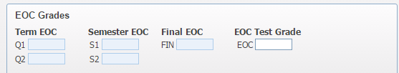
- **Note- Students who complete their Biology I requirement through dual enrollment are not required to take the Biology I End-of-Course Assessment (EOC). However, students who choose to pursue the “Scholar” diploma designation must pass the Biology IEOC. The EOC will be used for the designation only, not as 30 percent of the dual enrollment grade.

- Import Setup
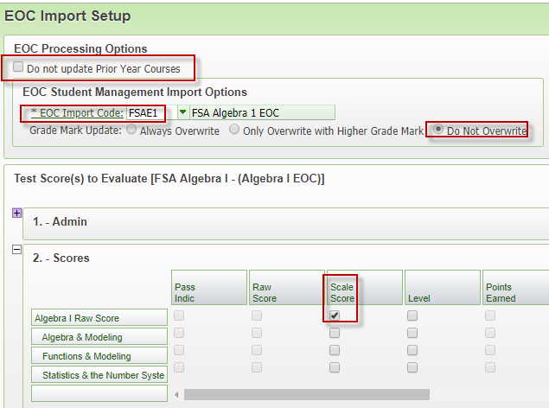
- Decide if you would like Prior Year Courses updated when Importing test scores. If you do NOT want the system to populate EOC score buckets for previous year’s courses then CHECK the box for “Do not update Prior Year Courses “
- Verify that your EOC Import Code is correct for the test you are working on.
- Verify that your Grade Mark Update is correct for the scores that are being imported. The most common choice will be “Do not overwrite”, however if you are importing scores for the Spring Administration, there may be students that took the test in the Fall or Winter Administration of the same year and have an improved score. In those cases, you will choose “Only Overwrite with Higher Grade Mark’.
- Verify that the radio button in the Scores section is set on the Scale Score column

- T-Score Setup
- Most of the necessary setup for Tscores on NGSSS tests has been done in previous years. FSA tests should have the radio button set on “Alternate Passing Score”.
- The “Alternate Passing Score Timeframe” should be 03/10/2015-12/31/2015. That is the timeframe in which FSA test were administered before Scale Scores were adopted in January of 2016.
- The actual *Alternate Passing Score” that gets entered here is specific to each FSA test.
FSAE1- APS= 489
FSAE2- Does not have an APS because there was not a comparable NGSSS Alg 2 test to use
FSAE3- APS= 492
- EOC Import Code Override should only be used if you created a separate Import Code for the APS test administrations in 2015 and had a separate conversion scale for that time frame in which to use as 30% of the final grade. We did not set these up because we were not required to use the scores from the 2015 test administrations as part of the course grade.
- Verify that the Tscore location is set to Scale Score. This is where the system will look to see if the student passed for purposes of determining the Passed Calculated Code in the EOC Assessment Details area.

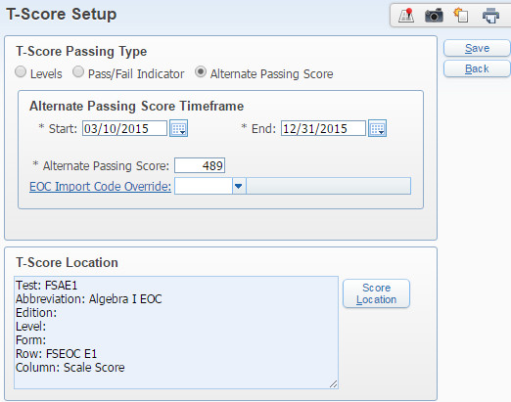

- Date Passed Setup –
- The following tests are used as Graduation Requirements tests and therefore necessitate the setup for Date Passed.
- FSAE1, FSARO, ACT, ACT New 2016, ECA 2012, FC2, FCA, PER, SA3, SA4
- Below is a screen shot of the FSAE1 setup
- Grade Level When Test Taken- 07-12
- Algebra 1 Raw Score- Radio button in the Scale Score column
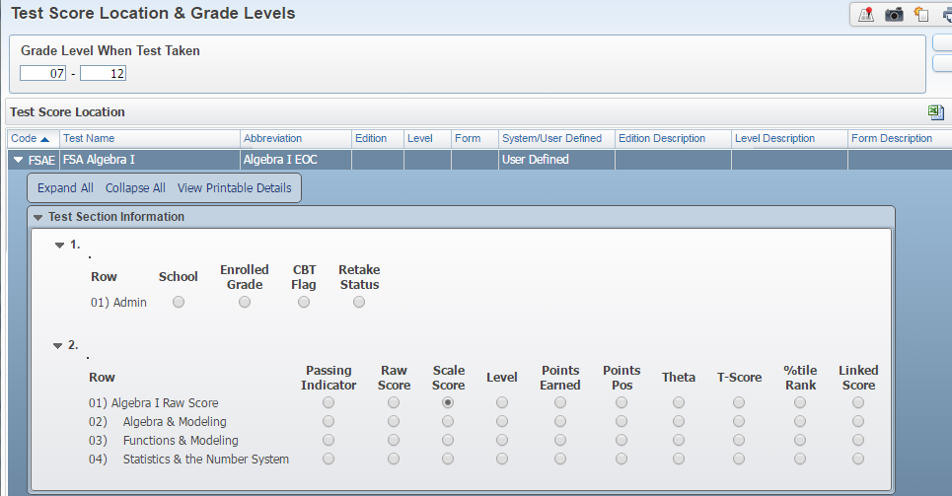

- EOC Calc Methods- From each entity- WS/OF/GR/PS/CF/GP/GP

The EOC Calc Methods tell the system which grade buckets to use when determining gpa and earned credit on EOC courses. The system looks at the regular Calc methods for the course grade set you are adding a new calc method for and adds an EOC grade bucket line for each row of grade buckets.
- Under GPA setup- click on EOC Calc Methods
** If you are opting to use the exam bucket in the gradebook to record the EOC grademark and have the gradebook calculate the final EOC grade, then you do not need to setup EOC Calc Methods. Proceed to step 7.

- EOC Grouping Codes-
- You first want to look at your EOC Grouping Codes. In order to do that, you have to edit one of your existing EOC calc methods and link to the EOC Grouping Code table.
- These codes can be whatever you want them to be. You can edit the existing description and you can create new codes, but you cannot delete any codes from previous years. Each group of courses (Alg 1, ALg2, Bio, Geo, USH, Civics) should have its own code. You do not need a separate grouping code for the Algebra 1 FSA and Algebra 1 ECA, because you can only link one grouping code to a course.
- The Algebra 2 grouping code is not needed for 1718
- Do not delete ALg 2 grouping codes used in previous years.

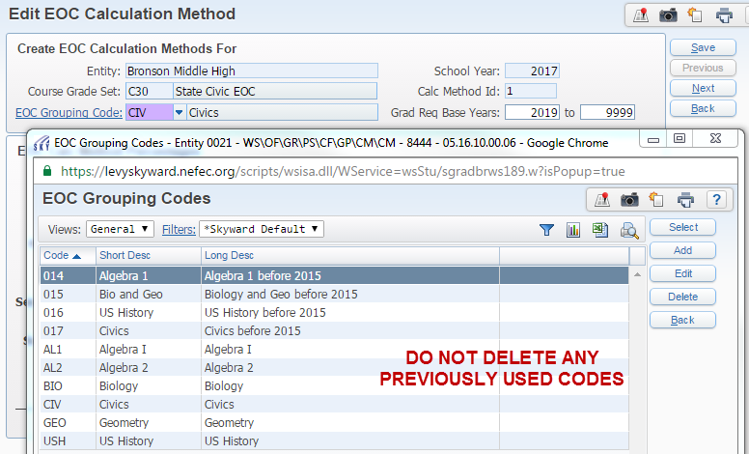

- Maintaining the EOC Calc Methods-
- You need a line for each test and each course length that you have an EOC course attached to in your course master.
- For instance, if you have Algebra 1 in your course master as a Semester and Yearlong course length, you will need a separate calc method for each course length for Algebra.

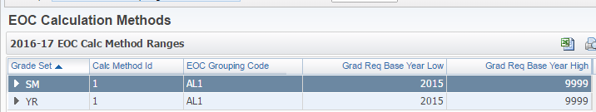

- Verify that the Grad Req Base Years range is correct for the corresponding EOC Grouping Code
- Verify that the calc method is set up to use the grade buckets you want it to use when determining the semester gpa, cumulative gpa, and earned credit for this group of EOC courses. You do this by entering a 100.00 in the bucket you want to use.

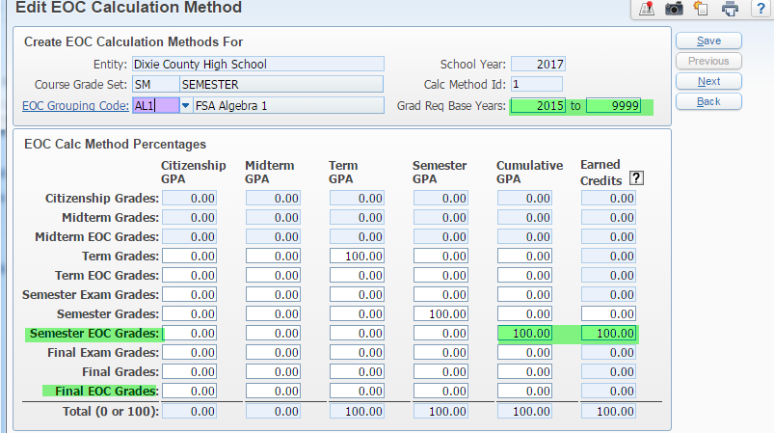

** Note- the system will only allow you to enter a 100.00 in the Earned Credits column if that grade bucket was used for earned credit on the original calc method.
** Note- some districts are choosing to use the regular semester grade bucket on the EOC calc method (instead of the semester EOC grade bucket) when determining cumulative gpa in the first semester for purposes of calculating a FHSAA gpa. Once the cumulative GPA including the first semester grades has been reported to FHSAA, they are changing the EOC calc method to use the Semester EOC grade for cumulative gpa. This is ok, because FHSAA wants to see all grades, even for EOC classes, included in the cumulative GPA when determining student eligibility. FHSAA understands that the GPA may change when EOC scores are received and final grades are calculated. If you choose to do this, make sure to run a Credit History Integrity Audit anytime you change the EOC or regular calc method.
Credit History Integrity Audit- WS/OF/GR/PS/UT- This utility should always be ran with extreme caution
The primary concern in keeping the cumulative gpa and earned credit coming from the same grade buckets within the calc method is that it will ensure that the gpa points and grade that prints on the transcript match.

- Course Master- From each entity- WS/OF/CS/BC/CM/CM
- Verify that all EOC courses have a grouping code attached
- You can run the “Course Report by Course” report (Office>Scheduling>Build Course Master>Reports) by setting the format in your template to User Defined and selecting that field in the Course fields column. You can then export the report to Excel and filtering/sorting on Grouping code.
- Otherwise you should check every EOC course at each entity to ensure the correct EOC grouping code is attached in the EOC area.
- You can also verify that the EOC test links are correct from the same area

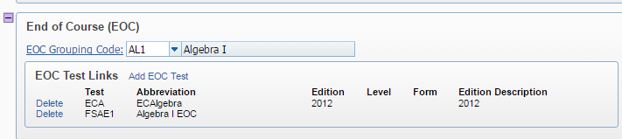

** Note- It may be a good idea to create a separate course length specifically for EOC courses in the course master. This makes it easier to filter in the course master as well as gives you the ability to isolate just one course length to make changes, if needed.

- Review Test Score Import Results reports
- Once test scores are imported into Skyward, you should receive a notice from John Colarusso at NEFEC as well as instructions on where to locate the Xcel spreadsheets and PDF reports resulting from the import process.

- Review the EOC Import Results PDF Report-
- Check for any unmatched demographic records that resulted in the test score information failing to load into Skyward.
- You will need to manually add these student’s test information on the test score tab as well as manually calculate the student’s final grade. The actual test score will be located on the Xcel spreadsheet, not the PDF.
- Check for any Xref table errors.
- Switching to the new option of processing by “Year” instead of “Entity and Year” should eliminate most of the errors we have seen in the past.
- There may still be some errors that reference no course for the student. The error will say “No Student Class record found for Student”.
- This will happen if the student is in fact is not enrolled in a course of which they are taking the test in the current year, (in which case they will be CAPing) or if the course the student is enrolled in is not linked properly to the EOC test in test builder.

- Run the “EOC Grade Calculation by EOC Import Run” Utility- From 000 or each entity- WS/OF/GR/PS/UT
If ran at entity level only student classes from the current entity in the Import Runs selected will be processed.

- Add a new template and select which test import to process -
- Click on “Select Runs’ to choose the test loads you want to run the EOC Grade calculation for. It is best to do one test at a time.
• When you check the box next to the import run you want, you can see the Student classes processed and the Exceptions that resulted from the test score import. That is basically the same information you saw when reviewing the test score import results PDF report. The exceptions will not be updated by this utility. You have to take care of those manually.
**It is a good idea to look at the “Student Classes Processed” so you know which courses you are updating when you run this utility. The “Student Classes Processed” browse will tell you the Entity, Year, all the students on the test file that will be processed and the course and section they are in. It does not tell you the course length or grade set of the class.

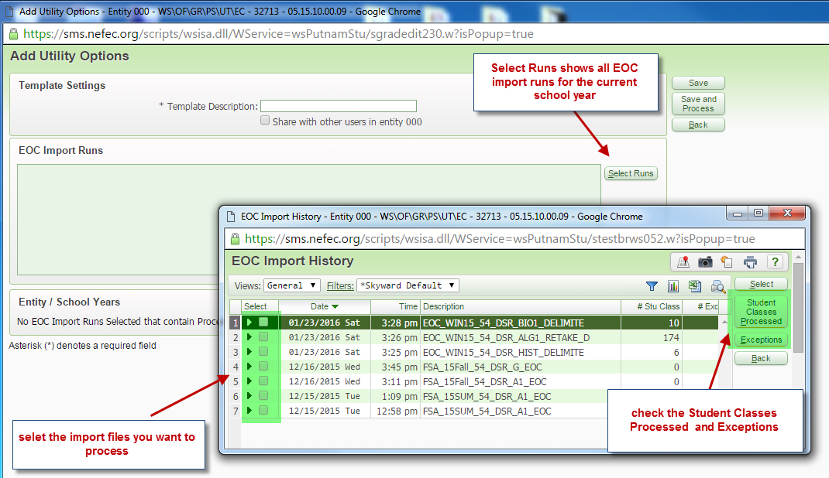

- Set up the calculation formula on your template and choose the appropriate Calc method-

- Based on what is selected in the step above, the screen will now have EOC Grade Calculation ranges for you to choose which EOC grade buckets to calculate and how to calculate them.

**You need to know if you are calculating a Semester EOC grade or a Final EOC grade for the courses associated with this test. So you need to know which course length set is attached to the courses you are running this utility for as well as which gradebucket your EOC Calc method is set up to use as Earned Credit.

If you are calculating Semester EOC grades, then your formula will be S1=70/EOC=30 and S2=70/EOC= 30

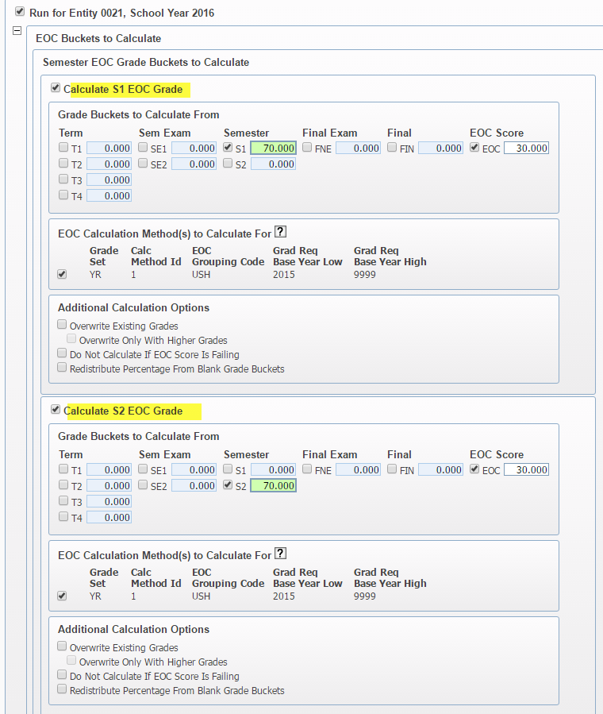

If you are calculating a Final EOC Grade, there may be two possible ways you calculate a FINAL EOC grade, either by semester grades and EOC or Final Grade and EOC.

Depending on how the Semester Final Default Formula is set up for calculating a Final Grade for this particular grade set- your formula will either be S1=33.3/S2=33.3/EOC=33.3 OR Final = 70/EOC=30
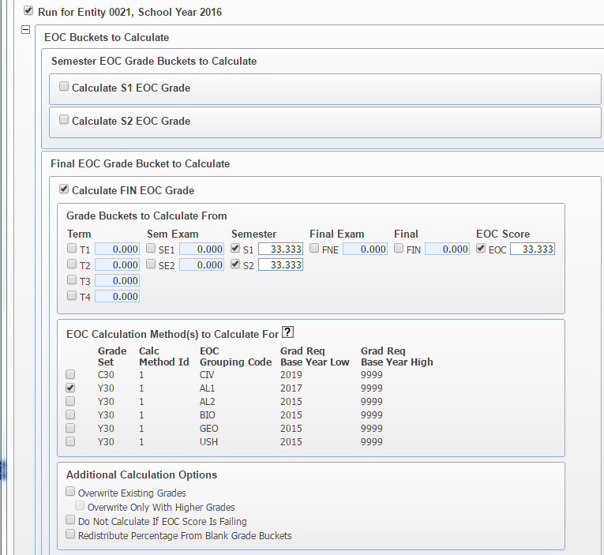

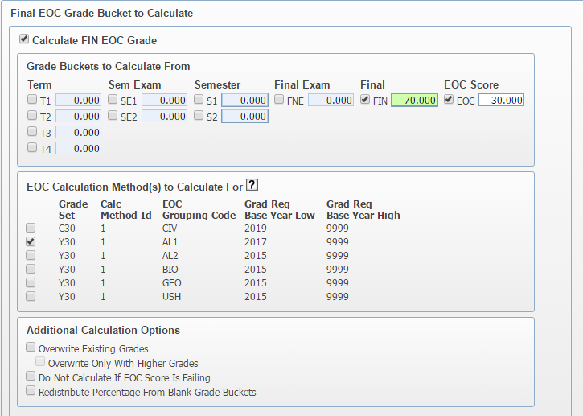
Make sure to check the box for the appropriate Calc Method formula to be used. If you are running this utility to process Algebra yearlong courses then you will check the box for Algebra grouping code and the corresponding grade set.

- Preview the Update –
- The utility will then provide a preview of the update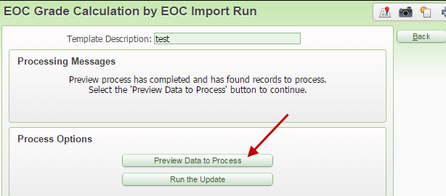
- You can remove selected students from the preview if needed
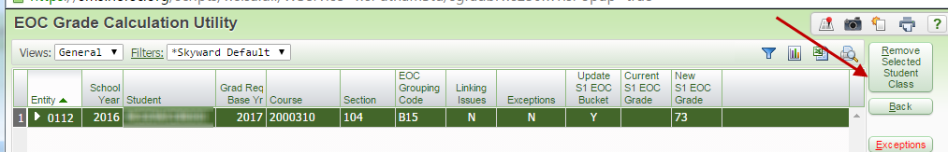

- Process the utility and review the report-
- Exceptions should be updated manually if they haven’t been taken care of already

- Hybrid Method using Gradebook
- Some Districts are opting to use the semester or final exam bucket in the gradebook to record the EOC Xref score and therefore setting up the semester final default formula to weight the exam bucket as 30%.

- This method eliminates the need to create EOC Calc Methods because you will not be using the EOC grade buckets. When the grade posts from the gradebook it will post in the regular Final grade bucket as opposed to the EOC Final grade bucket.

- This method also eliminates the need to run the “EOC Grade Calc by EOC Import Run” Utility. The grades are calculated inside the gradebook and posted when the grade posting window opens.

- There are some drawbacks to consider-
- This method works better when you are reporting one final grade in a yearlong EOC class versus reporting two semester grades in a yearlong EOC class. It also really helps to create a unique grade set specifically for EOC courses.

- Someone will have to enter the EOC Xref score into the exam bucket in the gradebook, it will not load automatically. This could present a problem if EOC scores are not back before teachers leave for the summer.

- Depending on when EOC scores come in, could require you to extend or re-open the grade posting window.

- The teacher cannot offer a final exam because the final exam bucket will be used for the EOC exam Xref score.

- You will see a message on all the EOC course grade records that says “EOC- Student Not Required to Take Test”. The system is programmed to show this message when the gradebucket used for determining earned credit is not an EOC grade bucket.
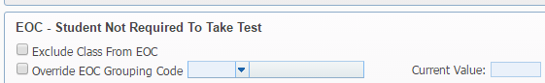
- There is a long standing PR to eliminate the message.

- How to Show EOC Scores and Grades as Viewable Columns in the Gradebook
- You can set up the Gradebook to show the EOC XRef Scores as well as the EOC Calculated Grade as a Viewable column in the Teacher’s Gradebook
From Each Entity- WS/EA/GB/PS/CF/ES
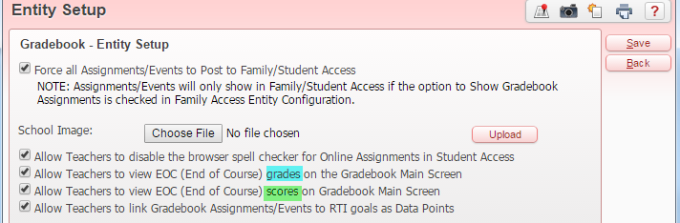
EOC grade buckets on a course calculating a Final EOC grade-
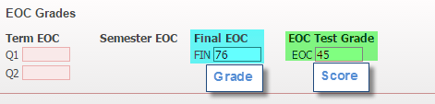
Gradebook main screen-
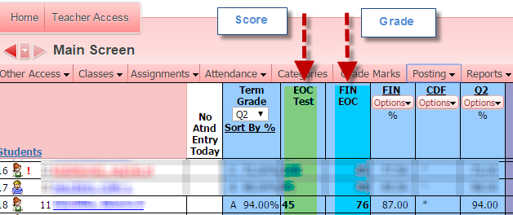

Revision History
12/07/2016 | Original Document Created
04/19/2018 | Changed Document name
04/19/2018 | Added note that Alg 2 EOC is no longer required.
04/19/2018 | Removed links to 1617 Fact Sheets
04/19/2018 | Added links to 1718 Fact Sheets
04/19/2018 | Included Note on the option for Updating Prior Year Courses on Import Setup

