Cash Receipts – Import

- Once your import spreadsheet is ready to import, in the web, please go to Web Financial Management\Account Management\General Inputs\Cash Receipts.
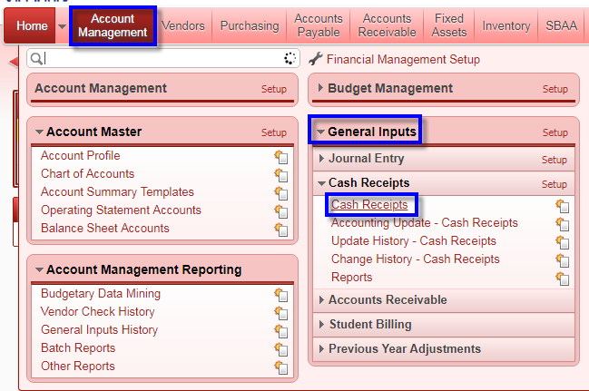

- Click the Add button.
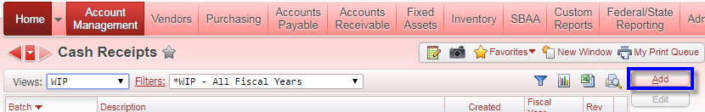

- Provide description, and then click the Save button.
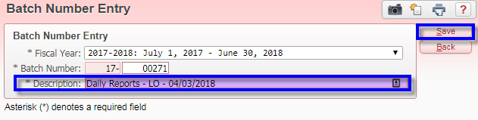

- Click on the Import Detail Lines button located on the right side of the window.
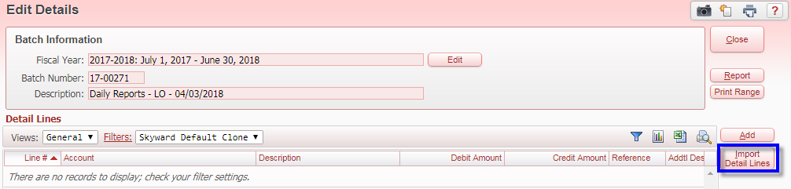

- Select the appropriate format from the dropdown box. Click the Choose File button to navigate to the files location on your computer. When ready, click the Run button.
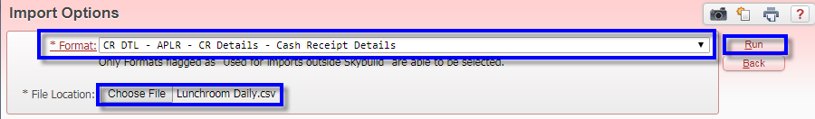
The process will run while you wait.
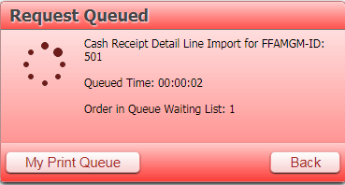

- Once the process has completed, click the View Report button to view and/or save report as needed.
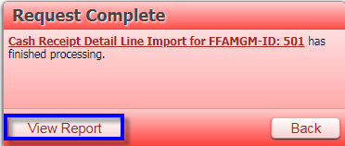
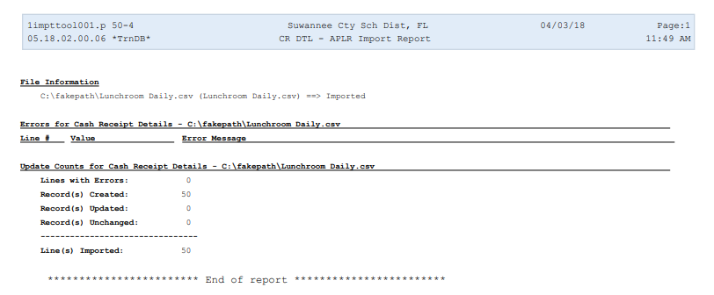
- At this point, all detail lines have been imported into the cash receipt. Verify amounts are correct as needed. Click the Close button. From this point on, processing the cash receipt follows the exact same procedure as manually created cash receipts.
