Add Bank & Create Bank Cash Account

Provide districts with the steps needed to create a new bank cash account in Skyward web.

Table of Contents
Add Bank 2
Enter Bank Information 3
Add Invoice from PO Number 5
Detail lines selected from PO 6
Save PO to Batch 6

Add Bank
Go to Web Financial Management\Account Management\Setup\Product Setup.
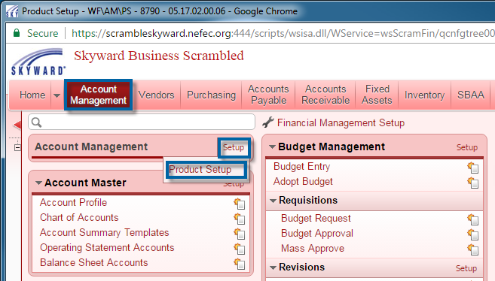
Click “Bank Names.”
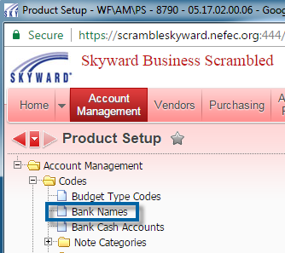
Click the “Add” button.
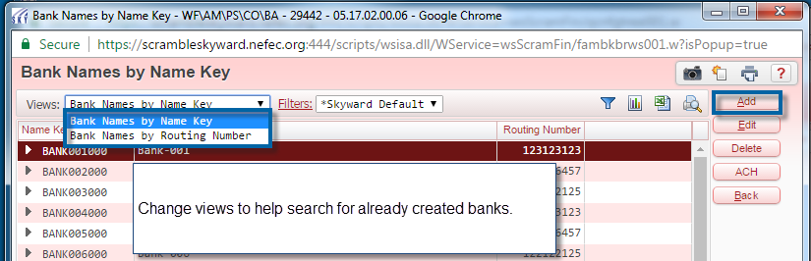

Enter Bank Information
After click the “Add” button, type the bank name into the “Organization Name” box, and click the “Click Here To Search for Entered Name” button. This will search through currently configured banks and through the vendor profile for the bank. If Skyward finds no previous record for the bank, then click the “Add Entered Name as BANK Name” button.
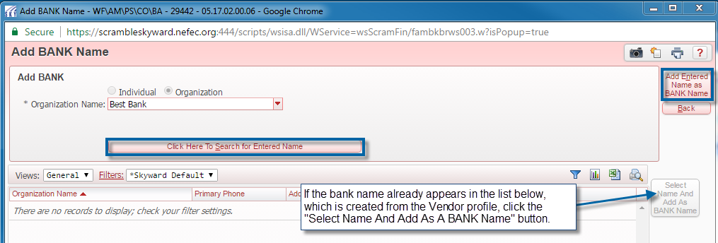
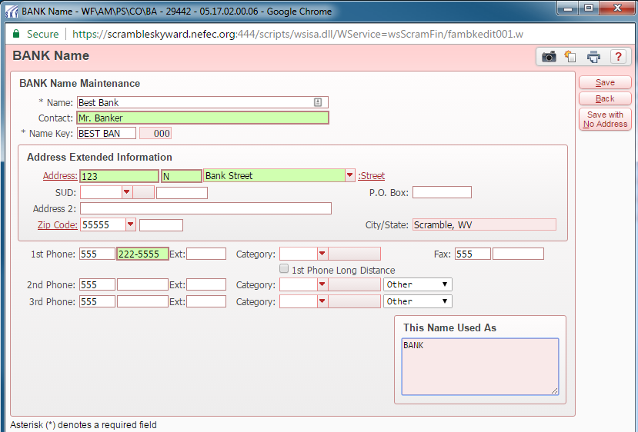
Enter the information for the new bank.
- Bank Name – Will automatically populate from the previous search screen.
- Contact – Optional
- Name Key – Will automatically populate. This field can be changed.
Enter bank address and phone information as appropriate, or click the “Save with No Address” if none is required.
If the bank will be used for ACH, check the “Accepts ACH Direct Deposits” box and enter the routing number. (***Please note*** The ACH settings and routing number can be changed at a later time by going to Web Financial Management\Account Management\Product Setup\Codes\Banks and then click on the “ACH” button.)
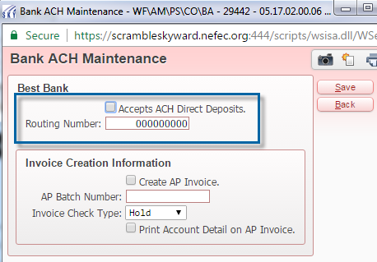
If necessary, specify the Invoice Creation Information.
- Create AP Invoice – An A\P Invoice is generally created if a bank permits direct deposits, but does not permit ACH transactions
- AP Batch Number – If A\P Invoices are created, specify the Batch Number to use automatically.
- Invoice Check Type – Regular or Hold
- Account Detail – Indicates whether Account Detail should be provided on the invoice.

Add Invoice from PO Number
To create an invoice from an existing purchase order click either the “PO Number” link or type the PO number. Clicking the “PO Number” link will open a view of existing purchase orders from which you can select the PO. You will need to click outside of the PO Number text box in order for the PO details to fill the invoice. After the PO fills the invoice master fields, you will still need to add the “Invoice Number”, “Batch Number”, and “Bank Cash Acct.” Update other fields as needed.

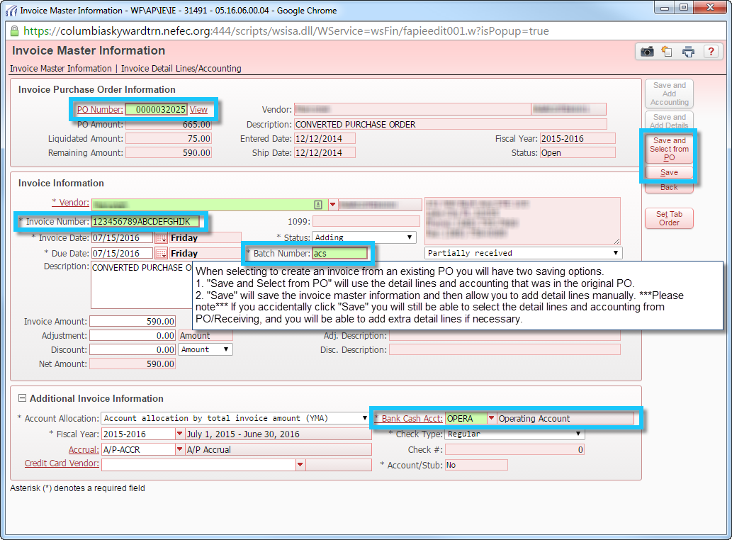

Detail lines selected from PO
From this view, the user can add detail lines from the original purchase order and/or manually enter detail lines.

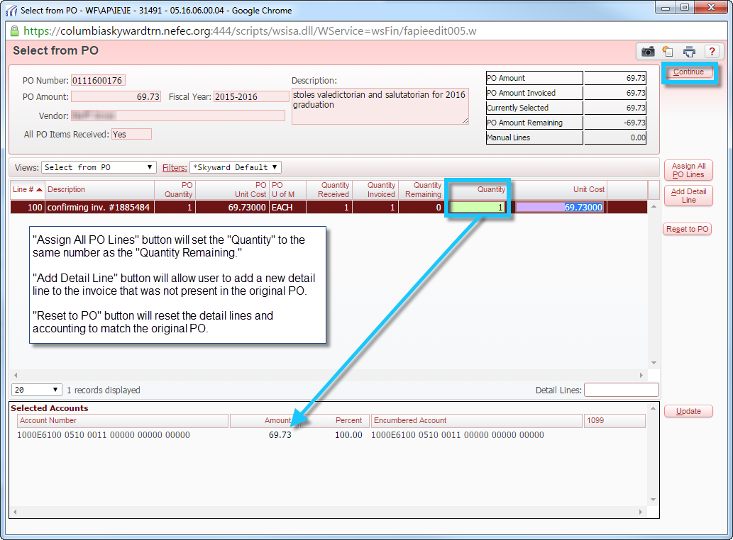

Save PO to Batch
After all the detail lines and account have been entered and the “Continue” button clicked, you will have a chance to review the invoice. If not corrections need to be made, click either the “Save” or “Save & Again” buttons as needed. Both buttons will change the invoice status from “Adding” to “Batch.” The invoice is now ready to be batch updated.

