Accounts Payable – Commerce Control Pay Export

- After all checks have been printed and AP check run has been completed, in the web, go to: Accounts Payable\Invoice Entry.
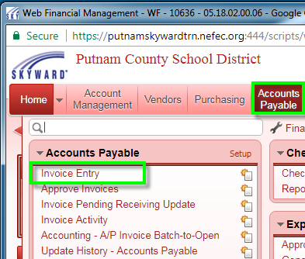

- From the Filters dropdown box, please select Commerce Control Pay Export. This will arrange all of the columns in this view into the correct format for Commerce Bank.
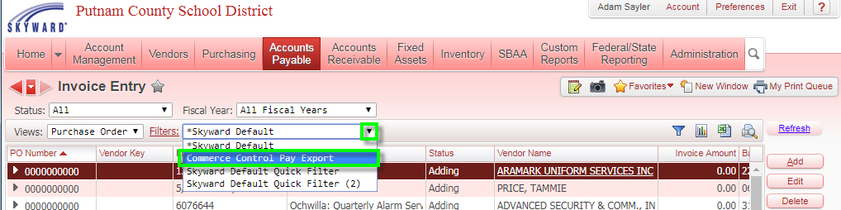

- Click on the Excel icon to export the arranged columns on the Invoice Entry screen to a .csv file. Select CSV and then click the Export button.
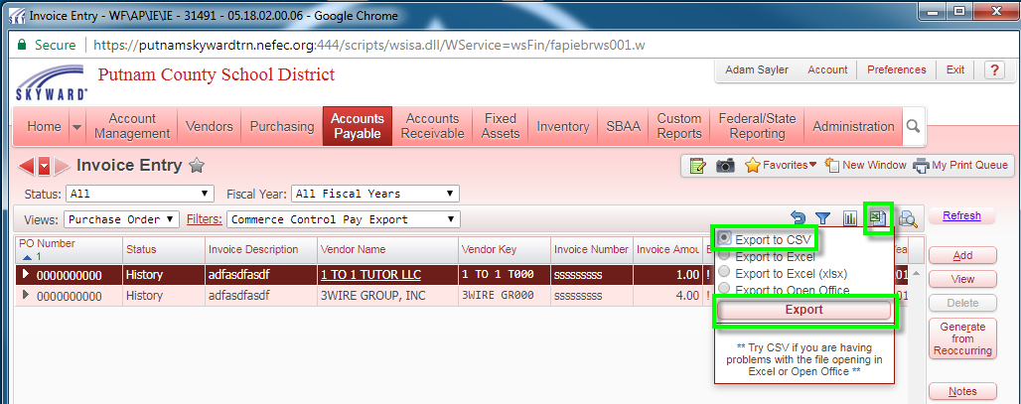
- Once the file has finished processing, click the Download Export File button.
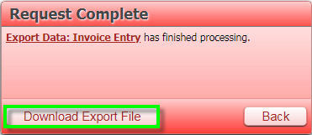

- Click the down arrow near the name of the downloaded file. Select the Show in folder option.
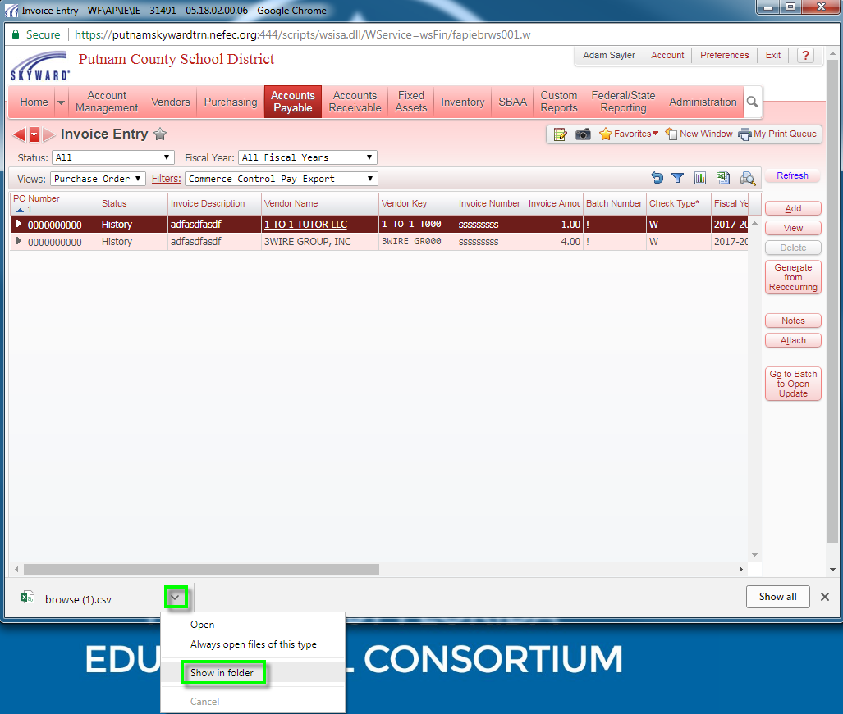

- This is your file. It is ready to be renamed as needed and uploaded to Commerce’s website.
