PO Numbers for Next Fiscal Year

Tutorial provides two methods for updating requisition/PO groups’ PO numbers for the next fiscal year.

Table of Contents
Navigate to Purchasing Utilities 2
Add Next Req/PO Number 6

Navigate to Purchasing Utilities
This method is best if the purchasing agent needs to update all purchasing order groups at one time.
- In the web, please go to Web Financial Management\Purchasing\Setup\Utilities.
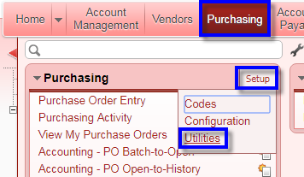

- Select the utility Mass Add Next Req/PO Number.
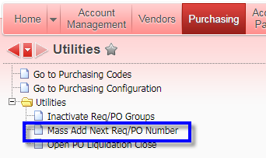

- Click on Select Req/PO Groups.
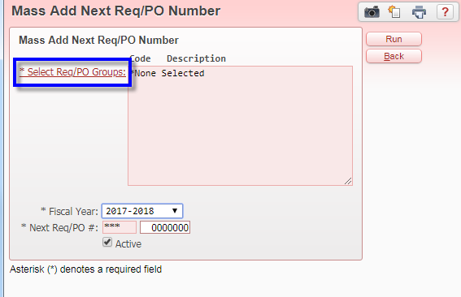

- Select the appropriate PO groups. Click Select All Codes to process all PO groups at once. After selecting the needed PO groups, click the Back button.
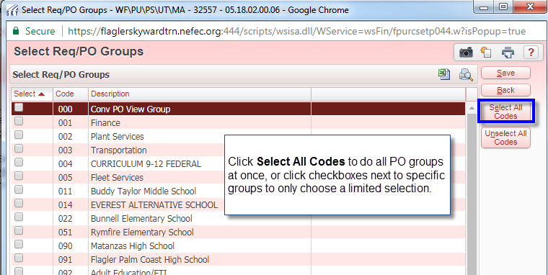

- After selecting the PO groups, set the fiscal year to the appropriate value. Put the Next Req/PO # field into the appropriate format, some districts use 1819 for fiscal year 18-19, other districts use 19 for the same fiscal year. Follow previous year’s pattern unless needing to make a change. At this point, you have the option to make these groups active or not. Once correct options have been selected, click the Run button.
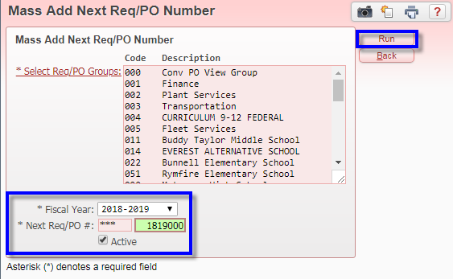

- Once the process has run, click the Preview Data to Process button.
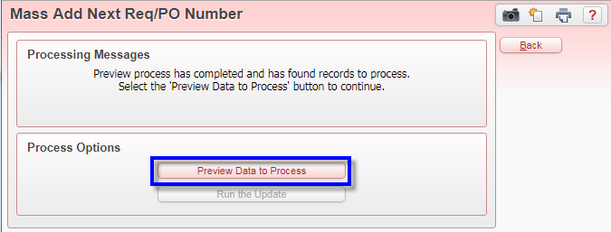

- Review the proposed PO group numbers for the next fiscal year. If everything looks good, click the Back button.
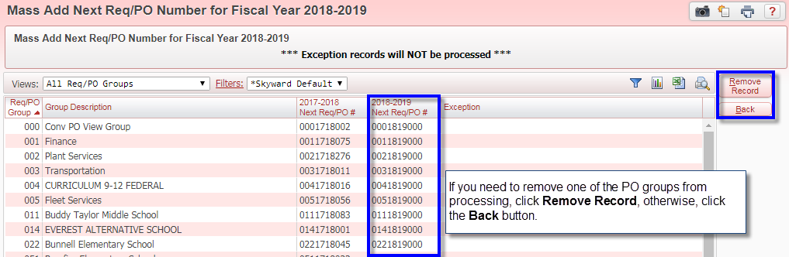

- Since after reviewing everything looked good, click the Run the Update button.
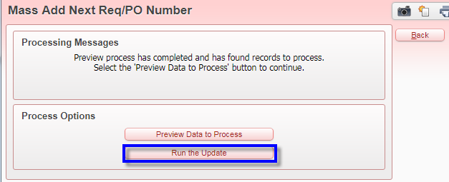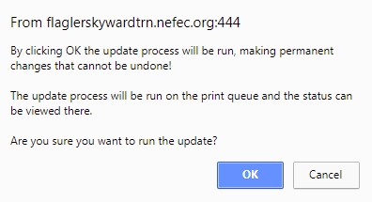

- The process will run in the Print Queue. Once it completes, Display Report to see the changes that were made. At this point, the process if complete.
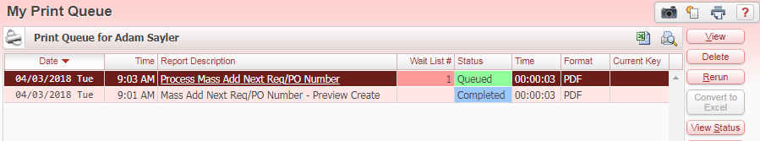
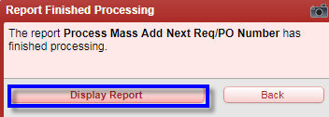
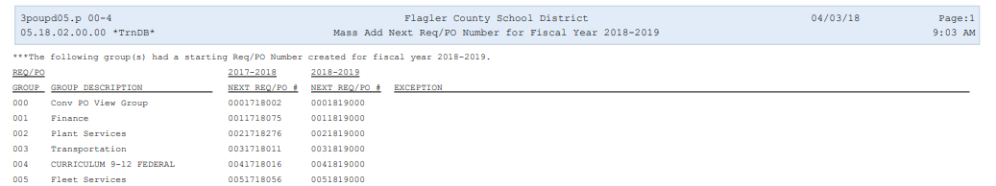

Add Next Req/PO Number
This method is useful if the district purchasing agent only needs make a change to a single purchase order group.
- In the web, please go to Web Financial Management\Purchasing\Setup\Configuration.
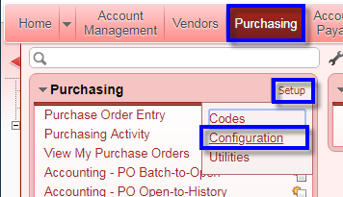

- Select Requisition/Purchase Order Groups.
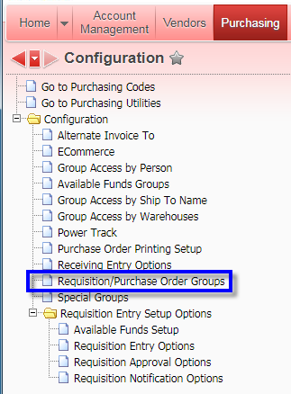

- Select the PO group that needs to have PO numbers created for the next fiscal year. Using the arrows on the left side of the screen, expand out the purchase order group. Look for Next Req/PO #. Expand that out, and then click Add Next Req/PO #.
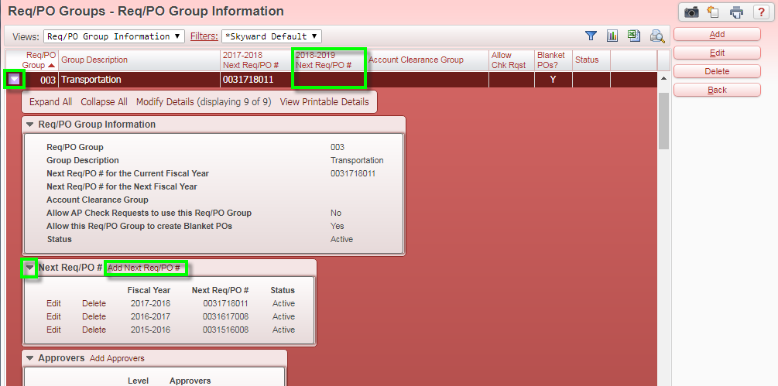

- Set the Next Req/PO # field to the appropriate format, and click the Save button.