After completing the Build Invoice part of the void/reissue process, you have an extra step because you will need to edit the newly created invoice to update the vendor.
- Please go to Accounts Payable\Invoice Entry.
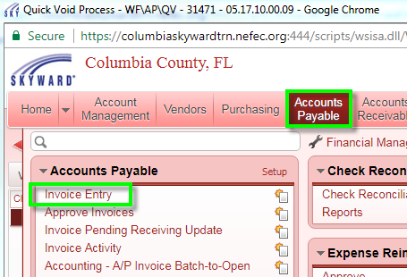

- Toward the right side of your screen, please click the quick filter button that looks like a funnel. Next, insert your batch number into the high and low value. ***Please note, if you allow the default batch number during the check selection process, your batch number will be the current date using the format MMDDYY, such as 011818 for January 18, 2018***. Click the Apply Filter button.
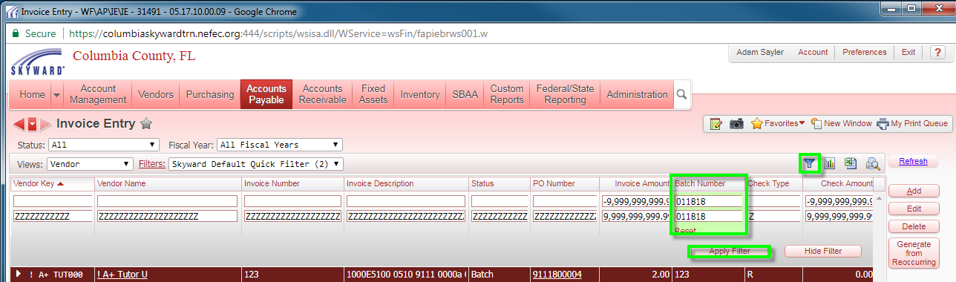

- Select the appropriate check type. Check type V is the record to be voided. You will need to select the invoice with a check type of W (wire) or R (regular/paper). Click the Edit button.
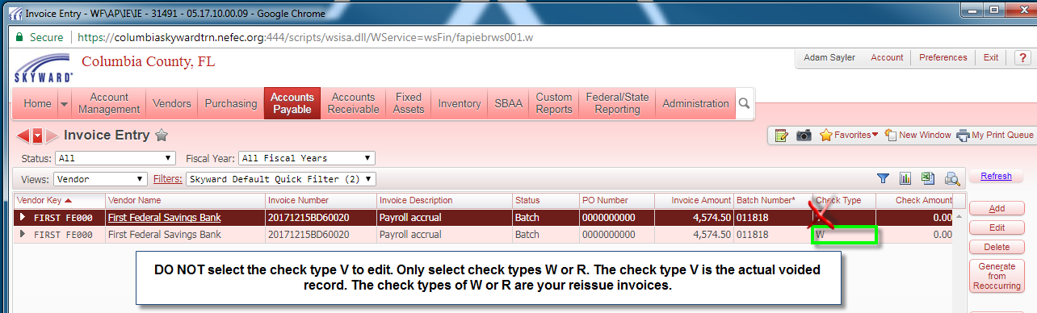
- Click the Edit Master button.
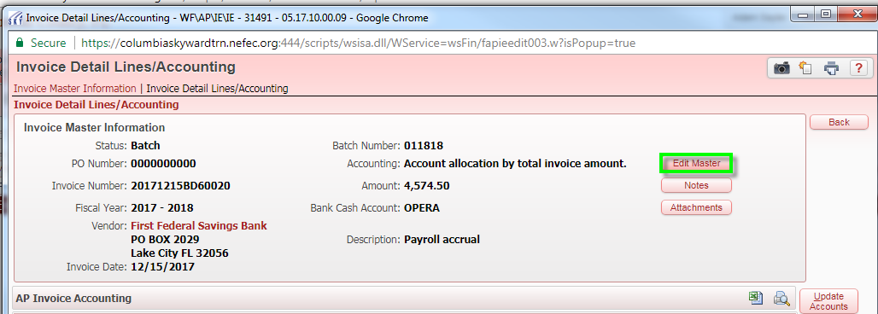
- Select the correct vendor. Click Save and Edit Accounting.
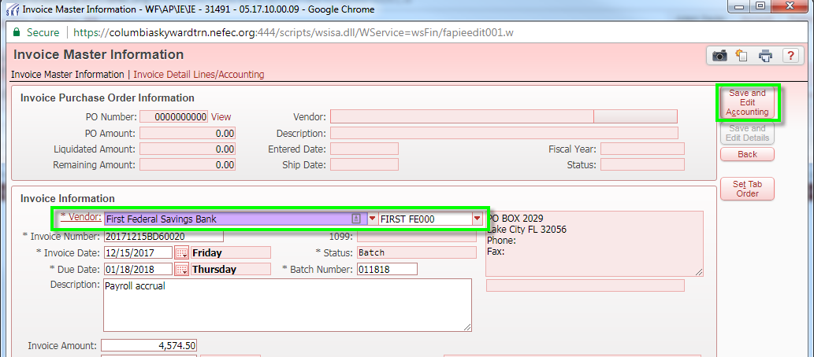

- Click the Back button.
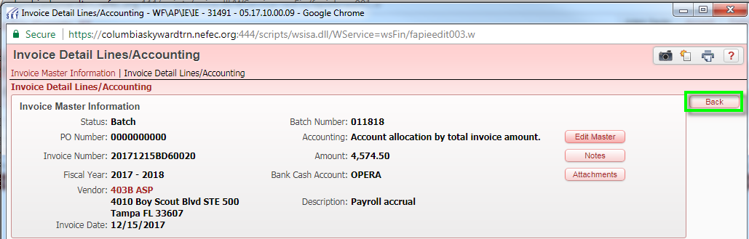
- Verify that the new vendor is correct. Then continue with the Batch to Open process and then your check register.
