General Inputs – Journal Entry Processing

- In the web, please go to Financial Management\General Inputs\Journal Entry\Journal Entry.
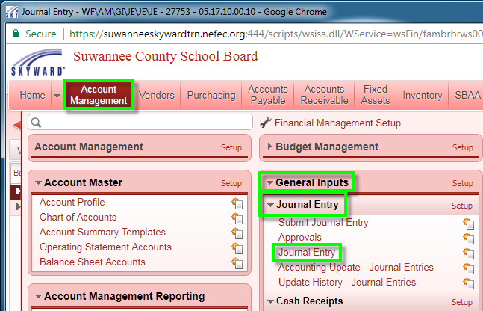

- Set Views to Batch.
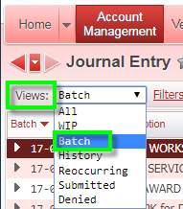

- Click the Go To Accounting Update button.
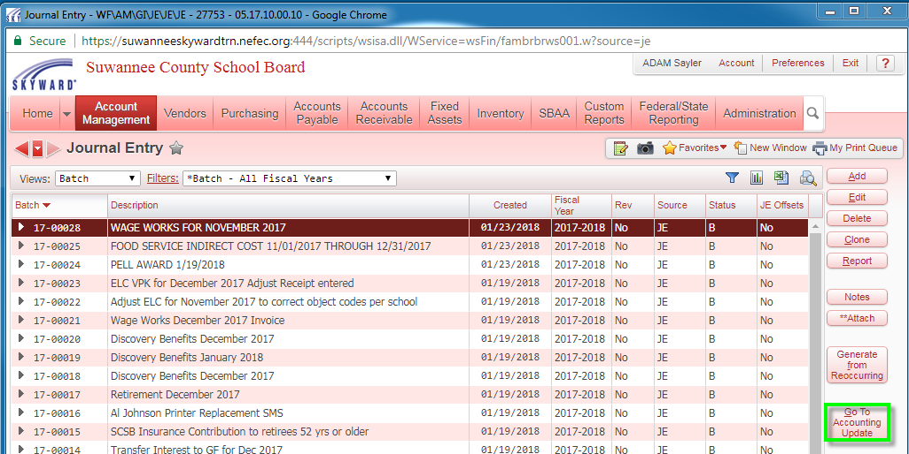

- Input batch range if needed. Click the Run button.
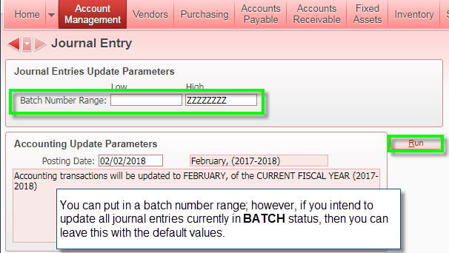

- Click Process Validation.
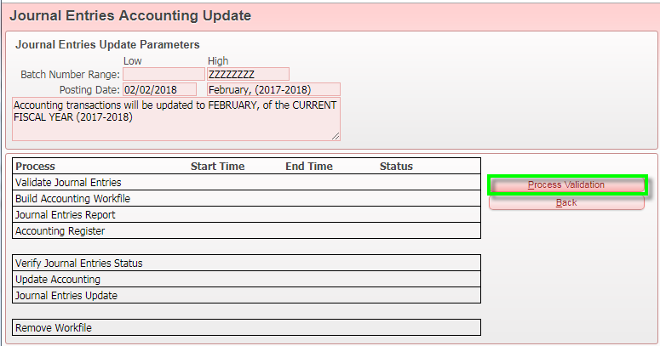

- Read, review, and print (as needed) Journal Entries Report and Accounting Register. If everything looks good, click the Update Accounting button. Nothing has posted, so you can still Cancel Accounting if you need to make changes.
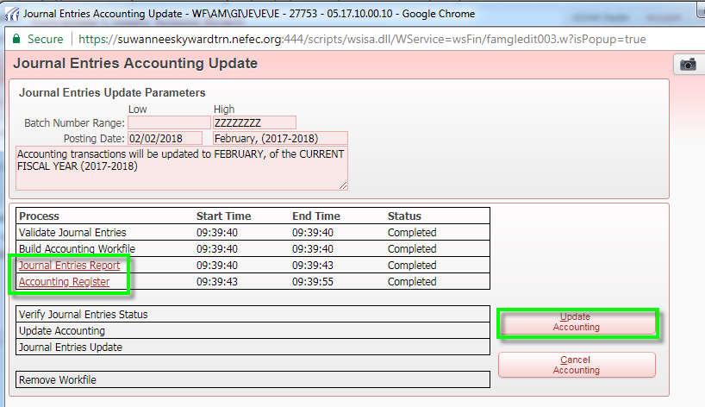
Click OK.
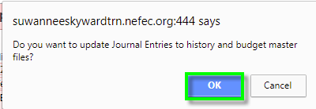
- At this point, the process has completed; click the Process Complete – Press to Close button.
