Accounts Payable – Accounting – A/P Invoice Batch-to-Open

- Go to: Accounts Payable\Accounts Payable\Accounting – A/P Invoice Batch-to-Open.
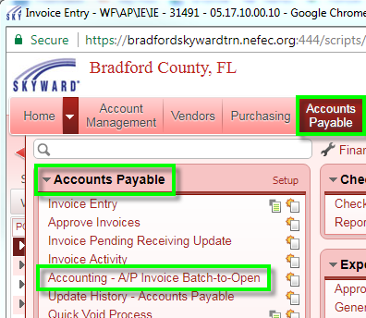

- Set your batch update parameters and options.
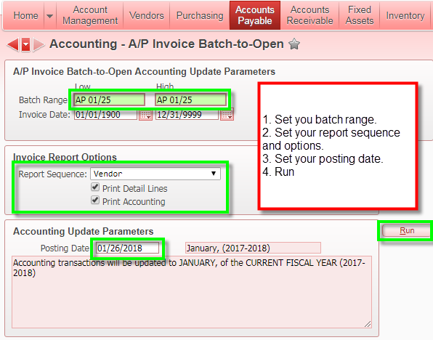

- Click the Process Validation button.
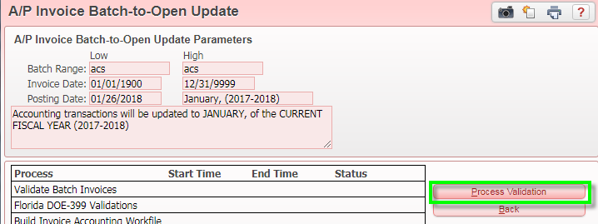
- Read and print reports (A/P Invoice Report and Invoice Accounting Register) as needed. Click Update Accounting.
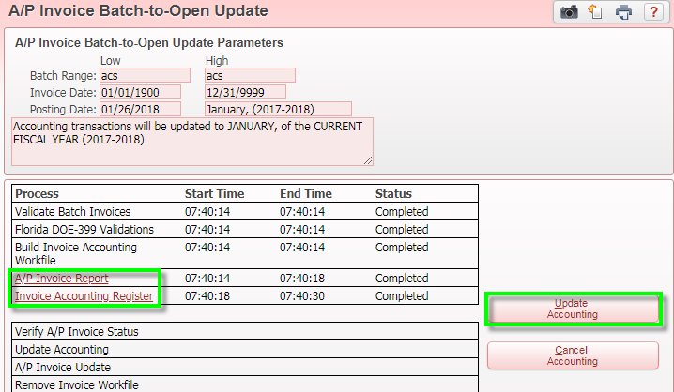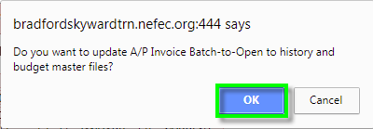

- At this point, your invoices have been changed from Batch to Open status. If there were POs attached to your invoices, Skyward will prompt you to process POs. That is an optional step at this point. We will create documentation for that soon.

