Set Scheduled Task to send email/notification within skyward
This allows districts to set scheduled task from their print queue for various reports that will send email and/or create a notification widget on the selected user’s dashboard. This process can be used to streamline work flow, as it consistently runs reports for users that traditionally have to remember to do on day-to-day basis.
Table of Contents
Navigate to Print Queue……………………………………………………………………………………………………………………………………………………2
Setting up the Scheduled Task………………………………………………………………………………………………………………………………………….3
Turn on Notification Widget…………………………………………………………………………………………………………………………………………….5
What Results can be expected………………………………………………………………………………………………………………………………………….6

Navigate to Print Queue
From anywhere within Skyward your print queue will always be to the right of the screen indicated by an emblem of a printer. Once you have your report you want to schedule select this emblem:
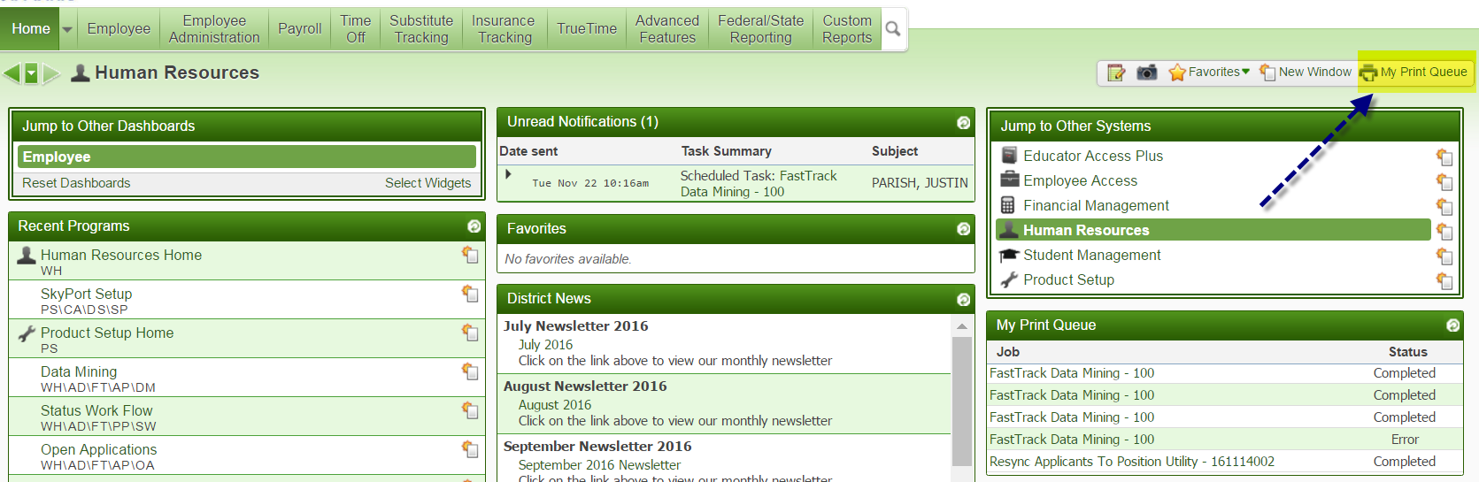

Once here, you will highlight on the report you wish to schedule and click task:
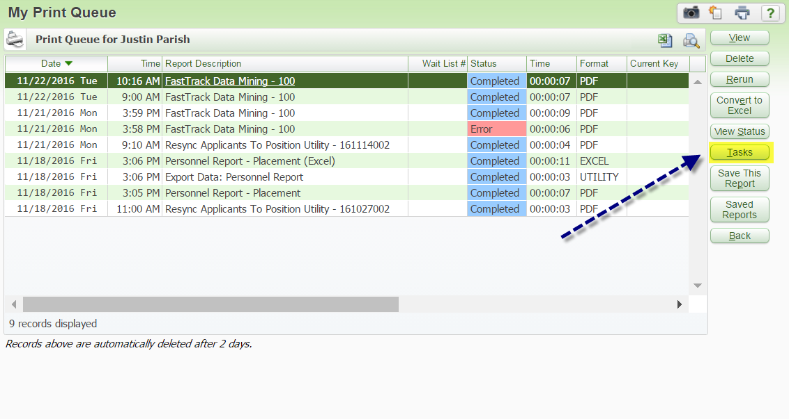

You will then be prompted with a screen with 4 options, you will want to select, “Schedule This”:

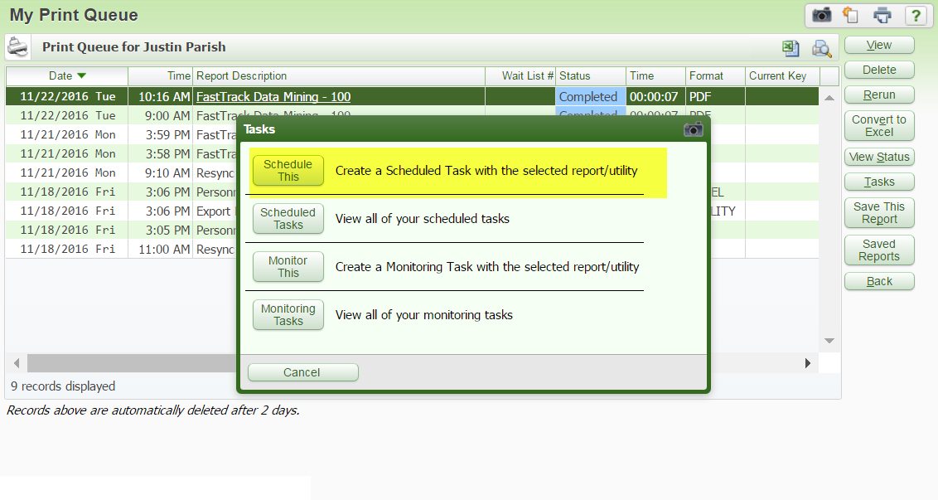
Setting up the scheduled task

Once you have selected “Schedule This”, you will be taken to the main set up screen. Here you will want to set up what days and time you want this task to run as well as whom you would like it to notify via email and/or notification. In the example below, I am scheduling myself to be emailed but Adam Sayler and I to both receive notifications. See screen shot on page 4
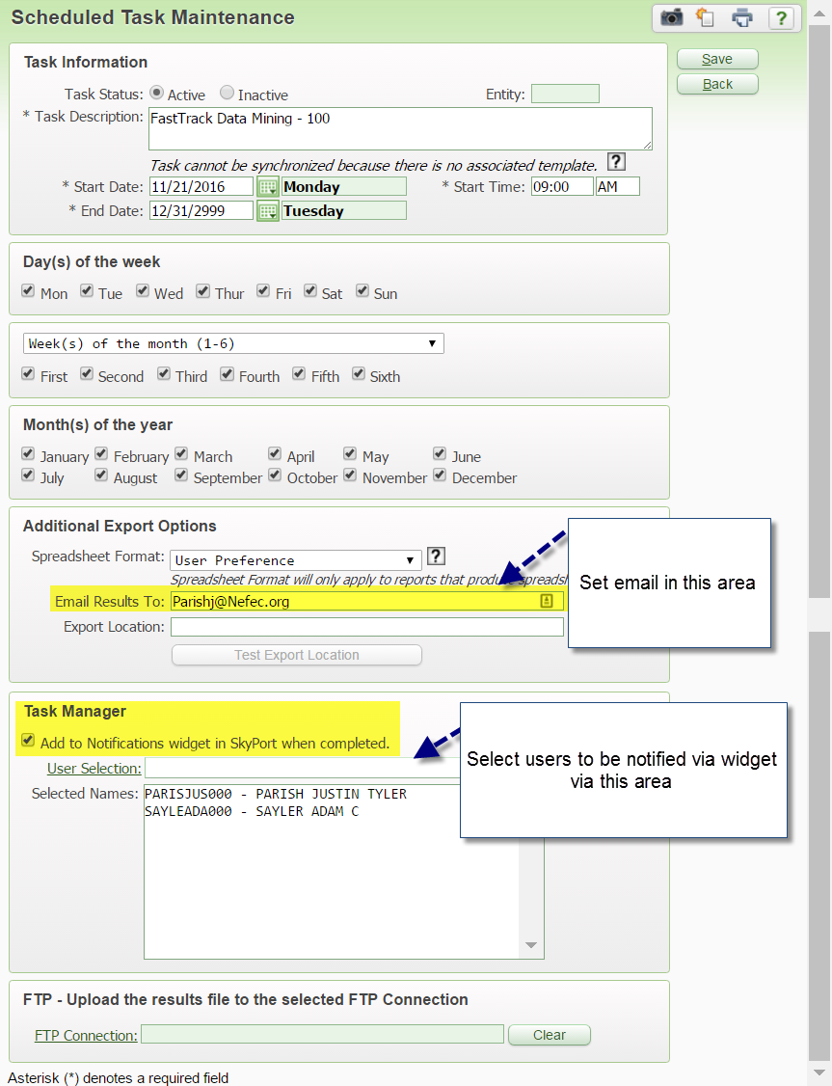

Turn on Notification Widget

Once your task has been scheduled, IF you have chosen to be notified via widget you will need to ensure the Notification widget is selected in your preference.

In order to turn this on navigate to your HOME tab and click “select widgets”

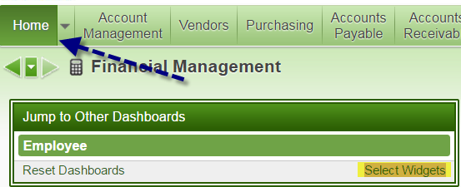

Once this is selected you will be prompted with a screen with various options of widgets, for this example you will want to check “Notifications”:

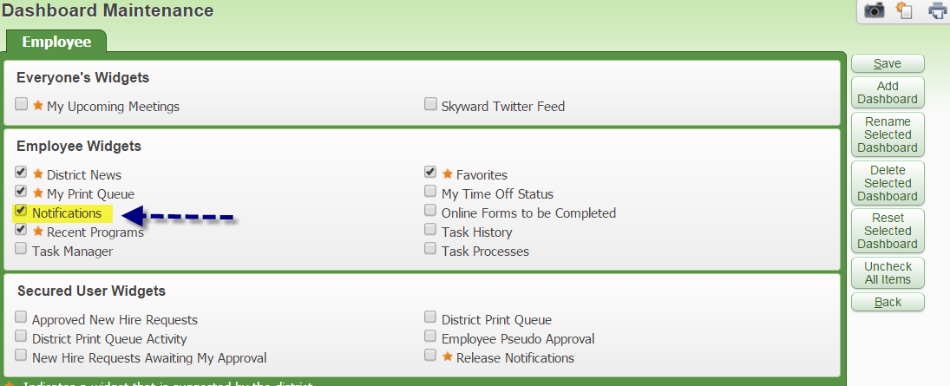

What Results can be expected

Once all the set-up is complete, the end results can vary based on where you wanted your notification to be received. If you selected email, you should receive an email at the time you selected the task to be processed.

The email will be indicated by the title “Skyward Processing” along with the title of your report. It will then prompt you to log in to view this generated report upon clicking the hyperlink:

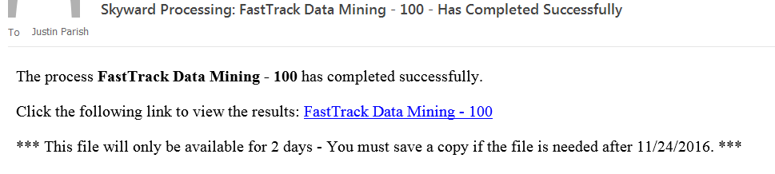

If you chose to be notified via the notification widget, this will populate at you HOME screen within skyward under Unread Notifications:

