Inventory Return to Warehouse

Provide districts with the steps needed to return items ordered from the warehouse.

Table of Contents
Navigate to Return Items Received 2
Add Return Request 2
Enter Return Information 3
Review Return Items Recieved 3

Navigate to Return Items Received
Go to Web Financial Management\Inventory\Inventory and then select Return Items Received.
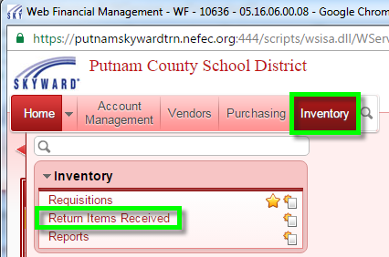

Add Return Request
Click the “Add” button to create a new return request.
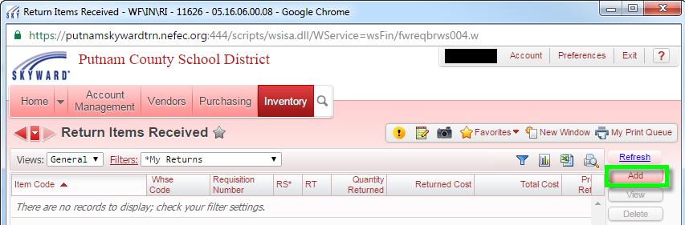
This will open a popup listing requisitions with the items you have received from the warehouse. Select the item you wish to return and click the “Select” button.
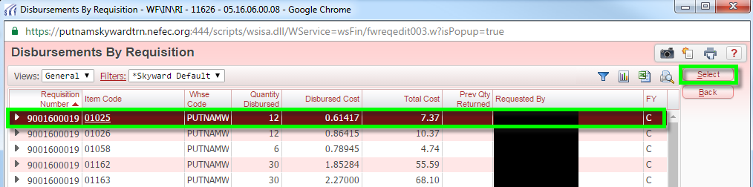

Enter Return Information
After you have selected the item to return, Skyward will launch the “Return Items – Maintenance” window. Type the quantity of the item that you wish to return. Next, select the return type. Add an option return note if relevant. Click the “Save” button. Once you have clicked the “Save” button your return request is complete.

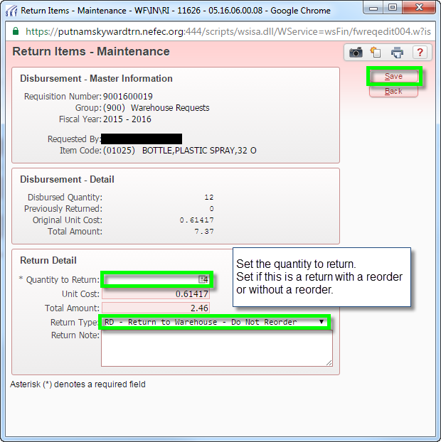

Review Return Items Received
From this view, you will be able to see the status of your return request and any relevant details.

