NEFEC Freshdesk Customer Portal

Provide detailed steps to activate a new user, create tickets, and check the status of existing tickets via the NEFEC Freshdesk portal.

Table of Contents
Activate NEFEC Freshdesk Account 2
NEFEC Freshdesk Home Screen 3
Create New Ticket 4
Checking Ticket Status 5

Activate NEFEC Freshdesk Account
NEFEC will send a new customer an activation email. This email will contain a link to the NEFEC Freshdesk website where the new user can create a password. Once the member creates a password, she/he will be able to create NEFEC call tickets, check the status of tickets, interact with other members through the forums, research solutions, and have live chat with available agents.
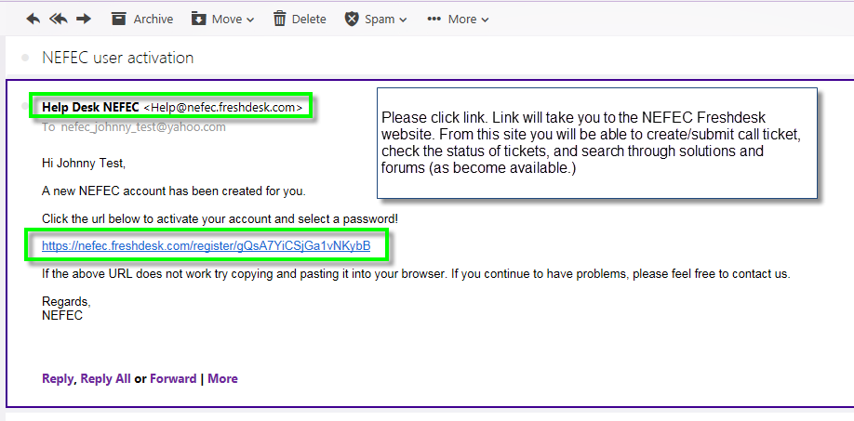
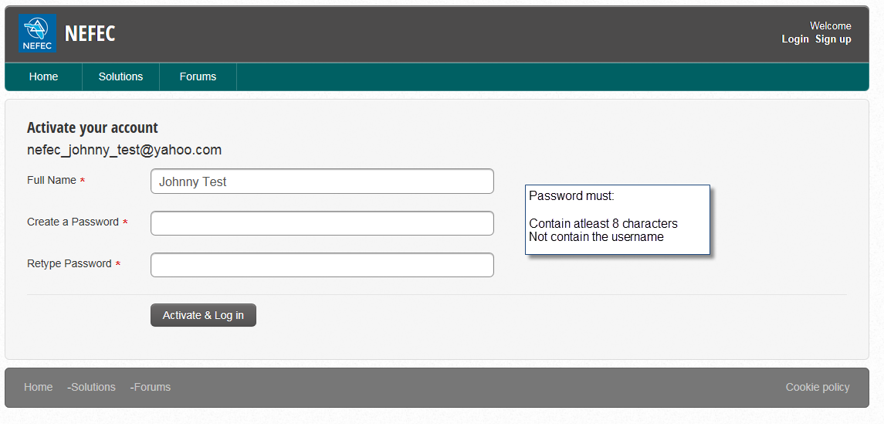

NEFEC Freshdesk Home Screen
From the NEFEC Freshdesk home screen, the user can create new tickets, check the status of tickets, read solutions and forums, and have a live chat.
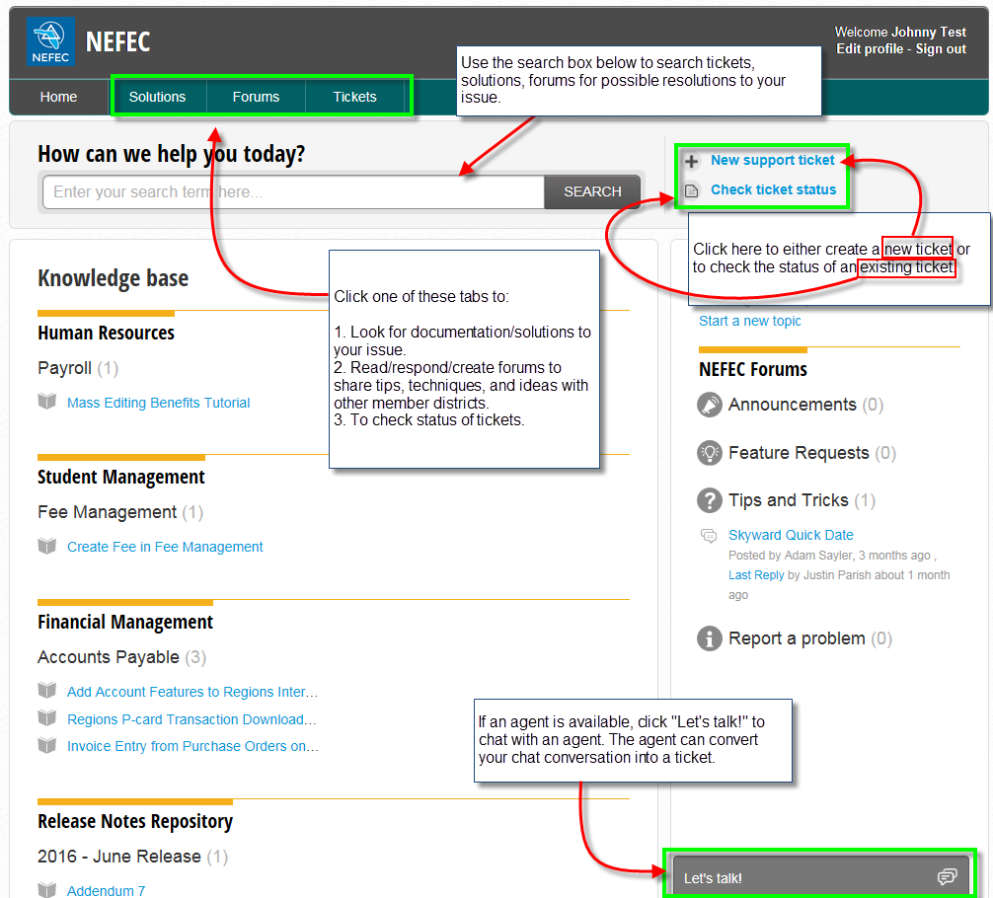

Create New Ticket
To create a new NEFEC support ticket, click “New support ticket.”
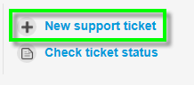
After clicking the link, fill in the required detail as shown below.

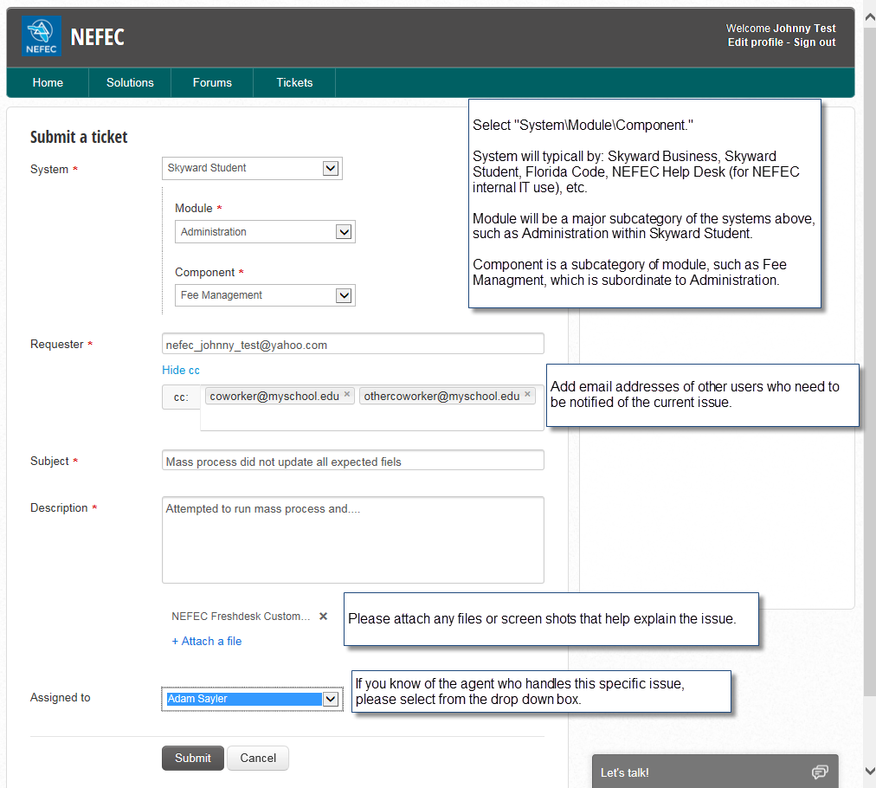

Checking Ticket Status
From this view, the user can check the status of a ticket or update detail to the ticket.

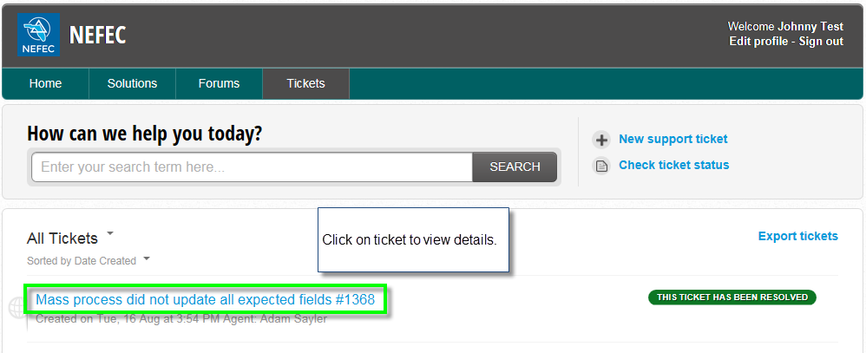
Once the user has clicked on the ticket, the user will have the ability to update the ticket, review what the agent has done with the ticket, fill out a survey, or provide further information to the agent.

