Invoice Entry from Purchase Orders

Provide districts with the steps needed to create an AP Invoice from existing purchase orders on the web.

Table of Contents
Invoice Entry 2
Add Invoice 2
Add Invoice from PO Number 3
Detail lines selected from PO 4
Save PO to Batch 4

Invoice Entry
Go to Web Financial Management\Accounts Payable\Invoice Entry.
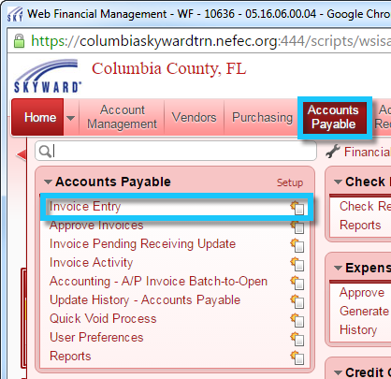

Add Invoice
Click the “Add” button to create a new invoice.
***Please Note*** If you edit an open AP Invoice the invoice, the status will change to batch status and will create a reversal record. You will need to run the batch update again to have the edited invoice return to open status.
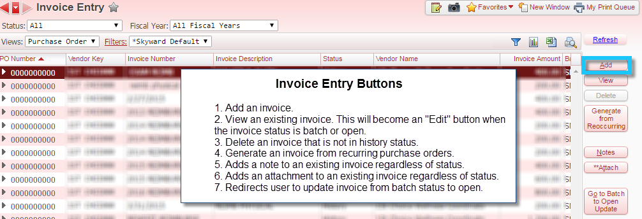

Add Invoice from PO Number
To create an invoice from an existing purchase order click either the “PO Number” link or type the PO number. Clicking the “PO Number” link will open a view of existing purchase orders from which you can select the PO. You will need to click outside of the PO Number text box in order for the PO details to fill the invoice. After the PO fills the invoice master fields, you will still need to add the “Invoice Number”, “Batch Number”, and “Bank Cash Acct.” Update other fields as needed.

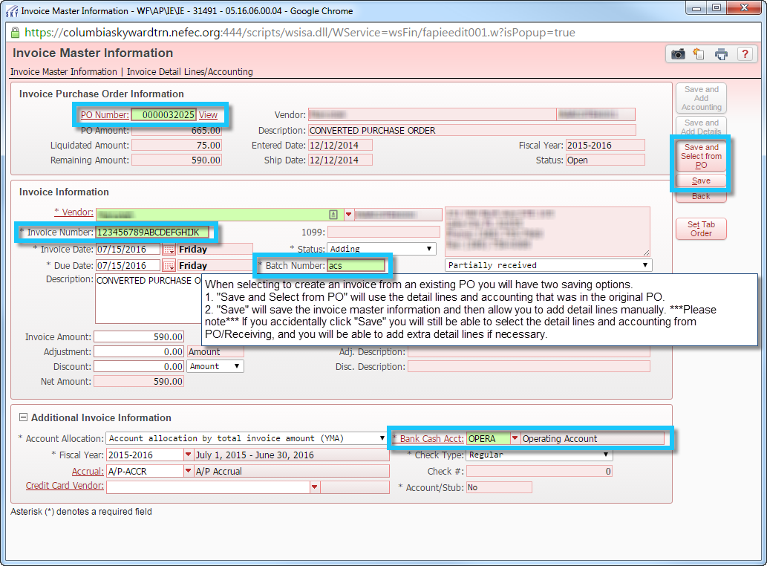

Detail lines selected from PO
From this view, the user can add detail lines from the original purchase order and/or manually enter detail lines.

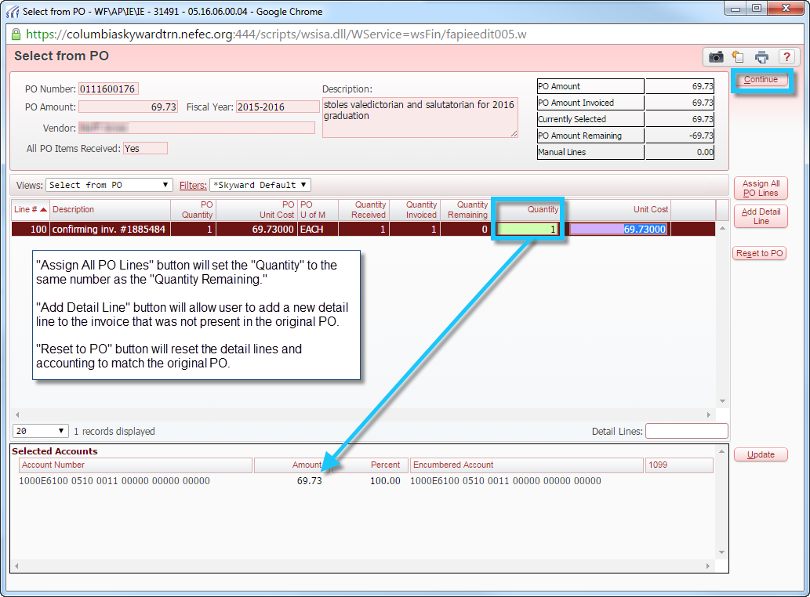

Save PO to Batch
After all the detail lines and account have been entered and the “Continue” button clicked, you will have a chance to review the invoice. If not corrections need to be made, click either the “Save” or “Save & Again” buttons as needed. Both buttons will change the invoice status from “Adding” to “Batch.” The invoice is now ready to be batch updated.

