Regions P-card Transaction Download & Conversion
Provides the steps to download the monthly transaction report from Regions and then to convert the file into the correct format for uploading into Skyward/PaC.
Table of Contents
Log Into Regions Website 2
Navigate to Report Studio 2
Process Report 3
Download Report 4
Run Macro (part 1) 5
Run Macro (part 2) 6
Edit Formatted File 8

Log into Regions Website
Go to the following URL https://intersect.regions.com.
Log in with Region provided credentials.
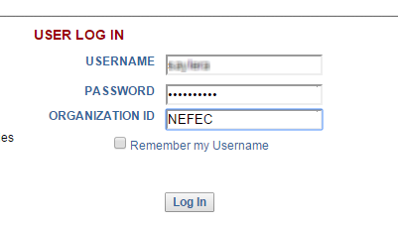

Navigate to Report Studio
Move computer mouse over the “Report Studio” menu item. Once the menu expands, click on “Company Reports.”
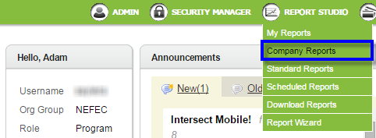
Select the report titled: “NEFEC Monthly Import.”
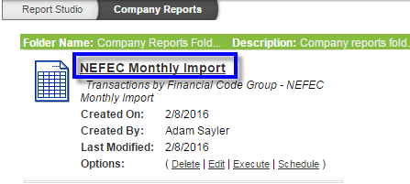

Process Report
Before clicking the “Submit” button at the bottom of the screen, verify that the screen displays “Hierarchy” and that the filters are set as in the screen capture below.
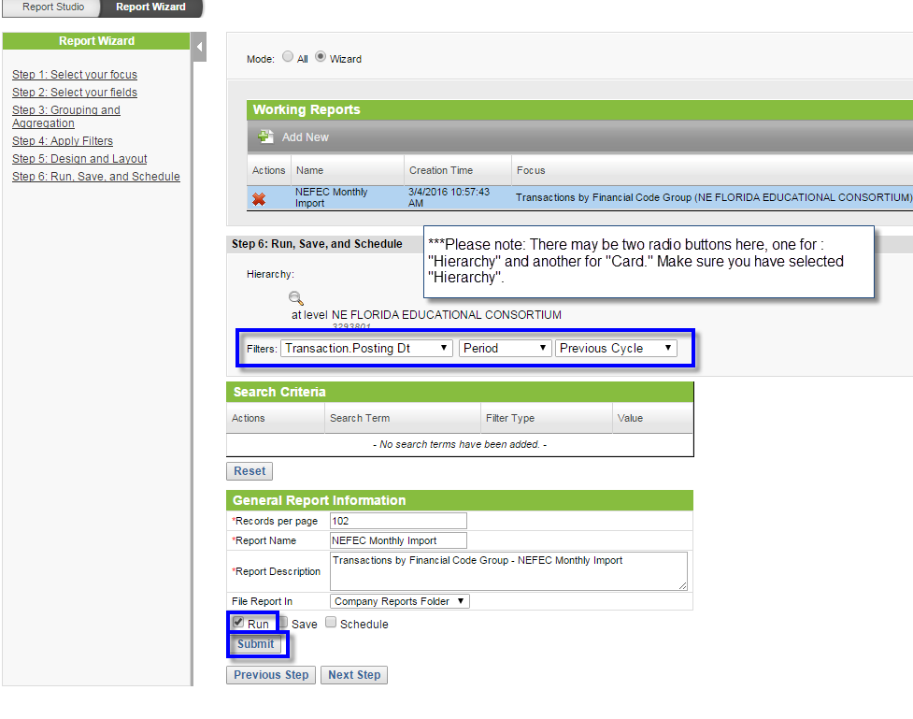

Download Report
From the dropdown menu, select “Excel 2007(xlsx)” and then click the “Export” hyperlink to the right.
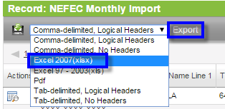
Once you click “Export,” the browser will begin to download a file. (This may vary depending upon the type of web browser you are using.) Go to the location on your computer to where you downloaded the file and then double click the file. This will open it into your computer’s unzip program.
Open a folder on your computer and navigate to \\nricdc.org\x-drive\NEFEC-Public\Educational Technology Services\Budgets\Regions\P'card Reconcilation & JE\. From the unzip program, drag the file into the Windows folder.
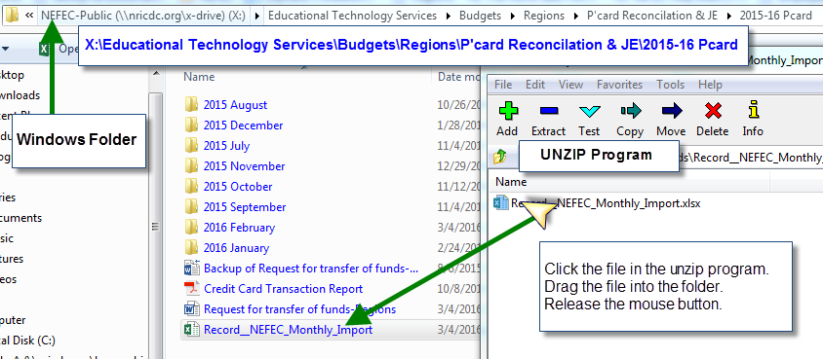

Run Macro (part 1)
Navigate to \\nricdc.org\x-drive\NEFEC-Public\Educational Technology Services\Budgets\Regions. Double click the Excel file titled “NEFEC Regions Card Converter File.
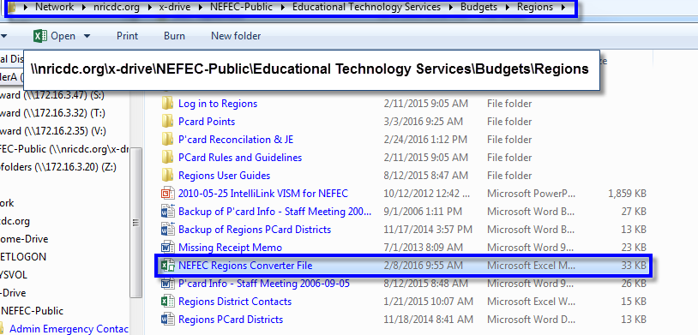
If this is the first time running the file, there will most likely be a security warning in Excel. Click the “Enable Content Button.”
There may be at least one, or possibly two, more security warning. Click “Yes” or “Enable” as necessary.
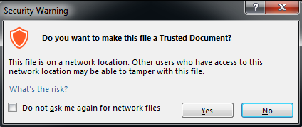

Run Macro (part 2)
Click the large grey button labeled “Click HERE to run the converter file.”
After click the button, Excel will open the Open file dialogue box. Navigate to X:\Educational Technology Services\Budgets\Regions\P'card Reconcilation & JE. Select the downloaded Region’s file and click the “Open” button. The macro will run and format the spreadsheet automatically.
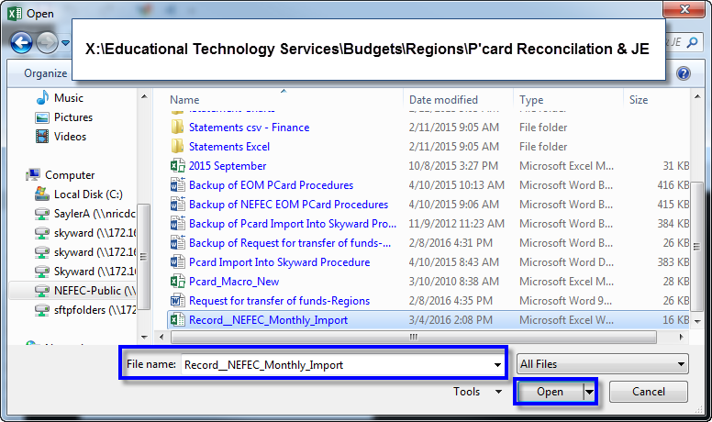

Once the macro has completed formatting the data, Excel will open the Save As dialogue box. Navigate to the appropriate fiscal year folder, such as X:\Educational Technology Services\Budgets\Regions\P'card Reconcilation & JE\2015-16 Pcard. Near the top of the dialogue box, there will be the option to create a “New folder,” click “New folder.” Type a name for the folder, using the format of Year and then Month. Next, double click the newly created folder and type a file name in following the format Month Name (i.e., March) and four-digit year. Click the “Save” button.
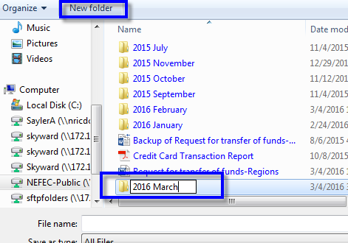
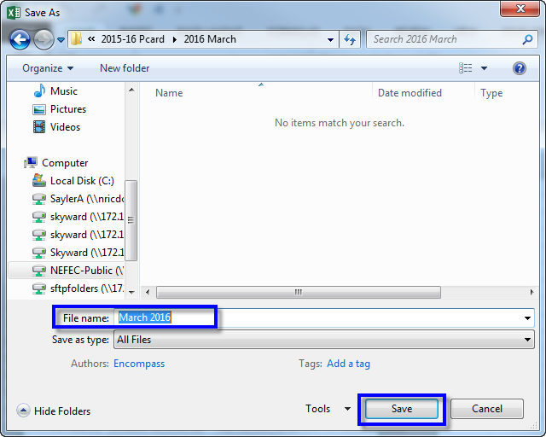

Edit Formatted File
The Region’s transaction report will contain a record of NEFEC’s payment for the previous month. Delete this transaction before importing into PaC. In order to delete the record, navigate to where the record you saved the file. ***IMPORTANT*** DO NOT DOUBLE CLICK THE FILE AND OPEN IN EXCEL THIS WILL REMOVE LEADING ZEROS*** Right-click on the file and select “Open with” and then “Notepad”. (If your computer has Notepad++ installed, use that to open the file, otherwise use Notepad.) Delete this line and make sure that there are no spaces between the rows/lines. Click “Save,” exit Notepad, and now the file is ready to be imported into Skyward or PaC.

