- Search for student from: Web Student\Administration\Fee Management\Customers
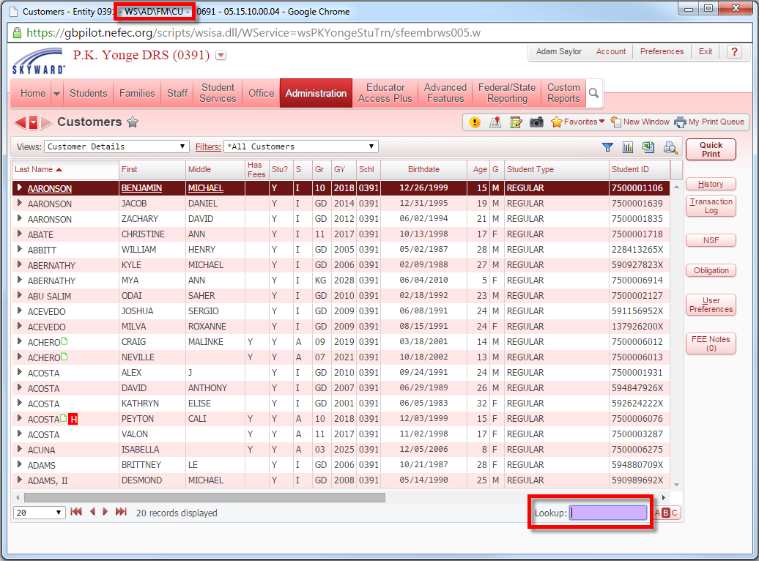
- Once you’ve found your student, expand the arrow by the student’s name and then expand the arrow for “Fee Activity.” Click “Add Charge.”
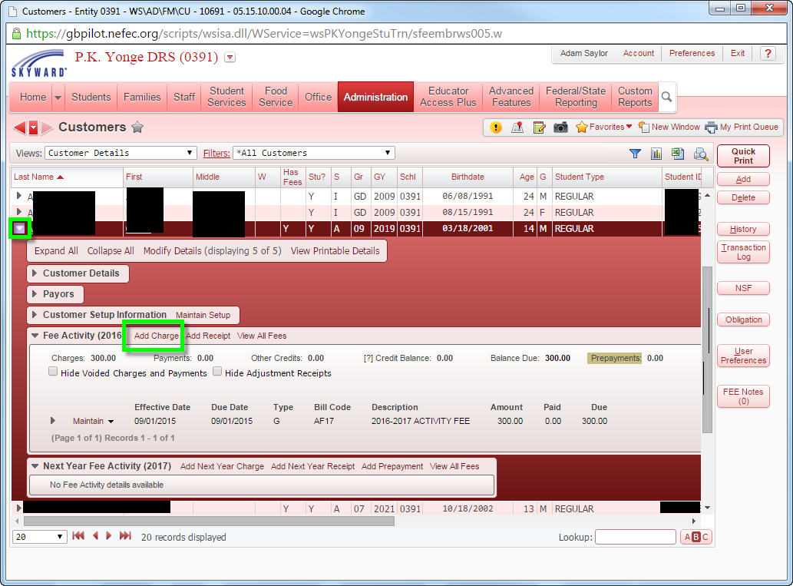

- An Add Charge dialogue box will open. Click the “Bill Code” link to bring up a last of Bill Codes.
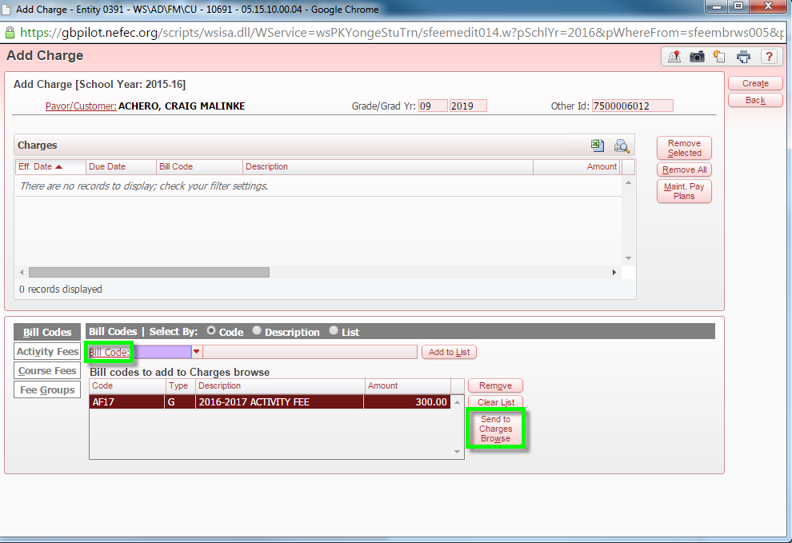
- Select the appropriate activity fee and then click the “Select” button.
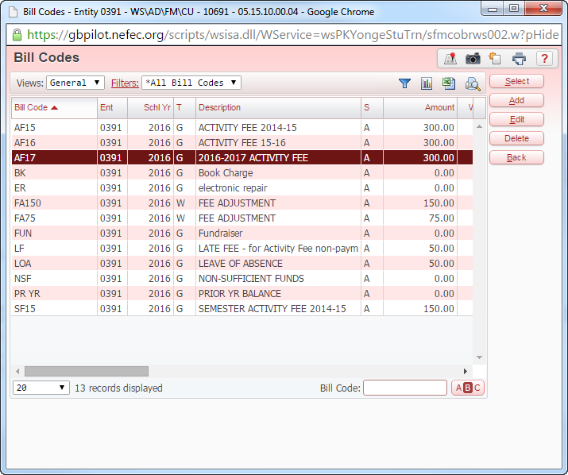
- Once all charges have been added, click the “Send to Charges Browse” button. This will load the bill code items into the charges portion.
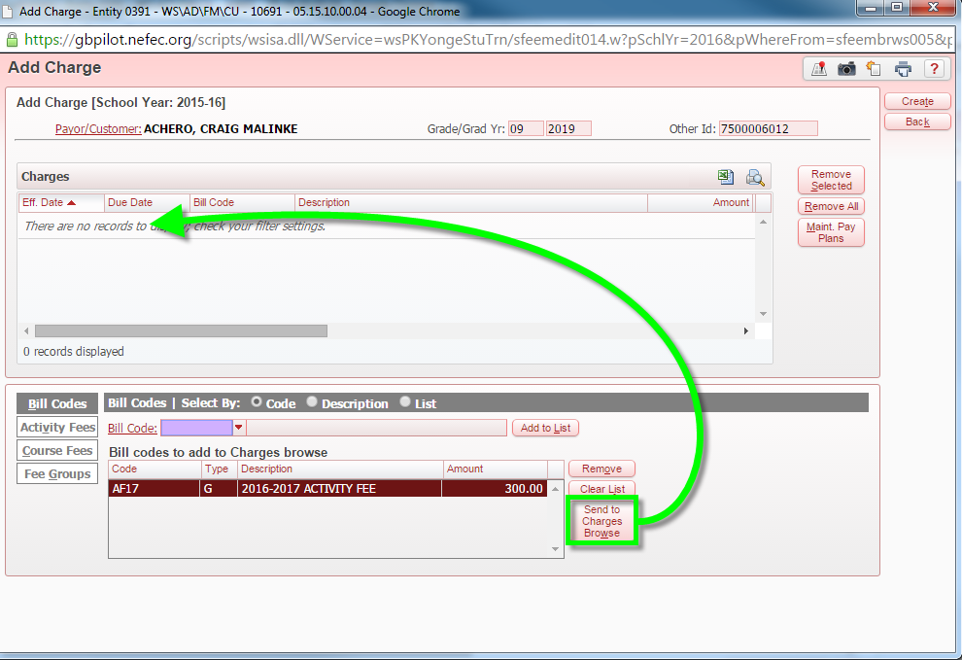
- At this point, you can edit the charges if necessary. Once you’ve completed any edits or modifications to the charge, click the “Create” button.
